DEVELOPING A LOW-COST DEVICE FOR ESTIMATING AIR–WATER ΔpCO2 IN COASTAL ENVIRONMENTS

Elizabeth B. Farquhar

A Thesis Submitted to the   
University of North Carolina Wilmington in Partial Fulfillment  
of the Requirements for the Degree of  
Master of Science

Center for Marine Science  
  
University of North Carolina Wilmington

2023

Approved by

Advisory Committee

Dr. Rob Whitehead Dr. Jessie Jarvis

Dr. Phil Bresnahan

Chair

Accepted By

Dean, Graduate School

TABLE OF CONTENTS

ABSTRACT iv

ACKNOWLEDGMENTS v

LIST OF TABLES vi

LIST OF FIGURES vii

INTRODUCTION 1

LITERATURE REVIEW 4

Section 1. Aquatic CO2 4

1.1 Why CO2 ? 4

1.2 pCO2 vs XCO2 vs fCO2 5

1.3 Measuring pCO2 and XCO2 7

1.3.1 NDIR Sensors 7

1.4 Calculating CO2 flux using ΔpCO2 9

1.5 Alternative Approaches for CO2 Flux Estimating 10

Section 2. Current Technology 12

2.1 Low-cost CO2 sensors (<$300) 12

2.2 CO2 flux sensors 13

2.3 Low-cost pCO2 systems 14

2.4 Gas permeability 14

2.5 Response time and τ 15

Section 3. Seagrass 16

3.1 Seagrass basics 16

3.2 Seagrass in NC 16

3.3 Importance 17

3.4 Carbon cycling 18

CHAPTER ONE: DEVELOPMENT OF THE SEACOW 20

Objective 20

Methods 20

1.1 Initial Design 20

1.2 K30 & K30 Housing 21

1.3 Flow of air inside the SEACOW 23

1.4 Electronics 24

1.5 Script 26

1.6 Outer Enclosure 26

Results 29

CHAPTER TWO: CHARACTERIZING THE SEACOW 30

Objective: 30

Methods: 30

2.1 Power Budget 30

2.2 Drierite Budget 31

2.3 Air side accuracy 31

2.4 Response time 33

2.4.1 Air side 33

2.4.2 Water side 34

2.5 Temperature 34

2.6 Humidity and Pressure Correction 34

Results 36

Air side accuracy 36

Air-side response time 38

Water-side response time 40

CHAPTER THREE: ASSESSING THE CAPABILITY OF THE SEACOW THROUGH SEAGRASS DEPLOYMENTS 41

Objectives 41

Methods: 41

1.1 Field deployment site information 41

1.2 Field deployment scheme 42

1.3 Tank experiment set up 43

1.4 Water samples and processing 45

Results: 47

Lessons from field deployments 47

Tank deployments 49

Aquatic pCO2 accuracy 51

CO2 Flux 52

DISCUSSION 54

REFERENCES 59

APPENDIX. 64

# ABSTRACT

Carbon dioxide (CO2) is of increasing interest to scientists and policymakers because of its role in climate change and the global carbon cycle. The ocean is one of the world’s largest carbon sinks, but closing the carbon budget is logistically difficult and expensive. Specifically, measuring the CO2 flux at the air–sea interface usually requires costly sensors or equipment (>$30,000), which can limit the area a group is able to monitor. However, our group has engineered a low-cost ΔpCO2 system for ~$1400 with Internet of Things (IoT) capabilities to combat this limitation in monitoring using a ~$100 pCO2 K30 sensor at its core. Our Sensor for the Exchange of Atmospheric CO2 with Water (The SEACOW) may be placed in an observational network with traditional pCO2 sensors to extend the spatial coverage and resolution of monitoring systems. After calibration, the SEACOW reports atmospheric pCO2 measurements within 2–3% of measurements made by a LICOR-850, which is considered an industry standard. We also demonstrated the SEACOW’s ability to capture diel pCO2 cycling in seagrass, developed recommendations for SEACOW field deployments, and characterized the SEACOW (e.g., air and water side 99.3% response time; 5.7 and 29.6 minutes, respectively). The SEACOW will be especially useful in areas where CO2 fluxes are variable, such as estuarine systems, and highly spatially resolved measurements are needed to fully capture the range of spatial variability.

# ACKNOWLEDGMENTS

I would like to thank my advisor, Dr. Phil Bresnahan, for his invaluable advice, continuous support, and patience during my research. His immense knowledge and experience have taught me an incredible amount about marine science and setting an example for others. I would also like to thank my committee members, Dr. Rob Whitehead and Dr. Jessie Jarvis, for their technical support on my study and for always answering my many questions with patience and expertise. This project would not have been possible without them. Additionally, Jimmy White, Dave Wells, and John Nunes from the Operations Wing provided me with encouragement and logistical support in the development and realization of my project. I am also grateful to Sunburst Sensors for providing me financial support for my second year of graduate school and for their insight into the oceanographic instrumentation field. Thank you to my fellow COAST Lab members: Gina, Jessie, Mitch, Stephen, and Luke E. for their great company and support in the lab. I’d also like to extend my gratitude to all the undergraduates, Russ, Dan, Luke C., Sophia, and Bentley, who have assisted me on this project. It is through teaching others that I found clarity in my own work. Without the friendship from members of my cohort and UNCW community, it would have been impossible to complete my study. Thank you sincerely, Caroline, Danielle, Russell, Nick, Devin, Kyle, Meg, Anna, Seanna, and Reanna for making Wilmington home. I would like to express my gratitude to my parents, my sisters, and to Bing for their continuous support and love throughout my time here. Additionally, the encouragement and laughs provided by my long-time friends, Lily, Kristina, Brendan, Lizzie, and Laura have been invaluable during my time here. Thank you to everyone who has made this work possible through their direct and indirect support of me.

LIST OF TABLES

Table 1. Summary of results from air-side dry calibration stepwise gas experiment. Pre refers to values that have not had the calibration curve applied, while post refers to those that have. SEACOW2 became inoperable and thus was excluded from this table. 38

Table 2. Averaged water quality conditions in the intracoastal waterway at Topsail, NC, as recorded by a YSI EXO2. 41

Table 3. Summary of the characterization data for the SEACOW 55

# LIST OF FIGURES

Figure 1. Overlapping absorbance peaks of CO2 (red) and H2O (blue). From NASA (https://earthobservatory.nasa.gov/features/EnergyBalance/page7.php). 8

[Figure 2. A visual representation of sensor response time and the sensor time constant. Created by Barani Design. https://www.baranidesign.com/faq-articles/2019/5/6/difference-between-sensor-response-time-and-sensor-time-constant-tau 15](https://uncw4.sharepoint.com/teams/COASTLab/Shared%20Documents/Farquhar/Thesis/Farquhar_Thesis.docx#_Toc152757143)

[Figure 3. A: The habitat distribution of H. wrightii (orange) and Z. marina (blue). B: The convergence of the Labrador Current and Gulf Stream. Figure adapted from Bartenfelder et al., (2022). 17](https://uncw4.sharepoint.com/teams/COASTLab/Shared%20Documents/Farquhar/Thesis/Farquhar_Thesis.docx#_Toc152757144)

[Figure 4. A model of the movement of carbon within seagrass meadows. (Lovelock http://dx.doi.org/10.1016/j.oneear.2020.07.010 ) 18](https://uncw4.sharepoint.com/teams/COASTLab/Shared%20Documents/Farquhar/Thesis/Farquhar_Thesis.docx#_Toc152757145)

Figure 5. The 3D-printed K30 housing with an O-ring. The wire holes are and top are sealed with marine epoxy. The BME 280 and K30 sensors are housed inside. It is 8.7 cm x 7.5 cm x 2.7 cm. 22

[Figure 6. The plumbing diagram using ePTFE as a planar exchanger for the air side and ePTFE tubing for the water side. 24](https://uncw4.sharepoint.com/teams/COASTLab/Shared%20Documents/Farquhar/Thesis/Farquhar_Thesis.docx#_Toc152757147)

Figure 7. Electrical block diagram for the components making up the SEACOW. 25

Figure 8. Air side planar membrane with the TMP117 sensor encased in a 3D printed housing. 28

[Figure 9. Water side cap with coiled ePTFE tubing and Blue Robotics temperature sensor. 28](https://uncw4.sharepoint.com/teams/COASTLab/Shared%20Documents/Farquhar/Thesis/Farquhar_Thesis.docx#_Toc152757150)

[Figure 10. An exploded diagram of the housing of the SEACOW. The retainer is secured onto the end cap, which screws into the O-ring flange. Inside of the 4 in diameter tubing is the electronics tray for securing the breadboard and K30 housing. 29](https://uncw4.sharepoint.com/teams/COASTLab/Shared%20Documents/Farquhar/Thesis/Farquhar_Thesis.docx#_Toc152757151)

[Figure 11. Set up for LI-850 Calibration. Gas flows into the sealed plastic container to mix before being read by the LI-850. 32](https://uncw4.sharepoint.com/teams/COASTLab/Shared%20Documents/Farquhar/Thesis/Farquhar_Thesis.docx#_Toc152757152)

[Figure 12. Set up for the gas experiments. Gas flows from the mass flow controllers (MFCs) into the mixing chamber, where it is read by the SEACOW and LI-850 and then pumped out by the internal pump in the LI-850. 33](https://uncw4.sharepoint.com/teams/COASTLab/Shared%20Documents/Farquhar/Thesis/Farquhar_Thesis.docx#_Toc152757153)

[Figure 13. Linear relationship between vapor pressure and K30 pCO2 readings: y = -3.2 +45x. 36](https://uncw4.sharepoint.com/teams/COASTLab/Shared%20Documents/Farquhar/Thesis/Farquhar_Thesis.docx#_Toc152757154)

[Figure 14. Stepwise gas experiment of all four SEACOWs vs the LI-850 before and after the dry calibration curve was applied. LI-850 XCO2 measurements were converted to pCO2 for comparison. SEACOW2 became inoperable and thus is excluded from these plots. 37](https://uncw4.sharepoint.com/teams/COASTLab/Shared%20Documents/Farquhar/Thesis/Farquhar_Thesis.docx#_Toc152757155)

[Figure 15. Response of several materials to a sudden change of CO2 concentration at time 0. 38](https://uncw4.sharepoint.com/teams/COASTLab/Shared%20Documents/Farquhar/Thesis/Farquhar_Thesis.docx#_Toc152757156)

[Figure 16. Response of the SEACOWs to a sudden change of CO2 concentration. SEACOW2 became inoperable and is thus excluded from this plot. 39](https://uncw4.sharepoint.com/teams/COASTLab/Shared%20Documents/Farquhar/Thesis/Farquhar_Thesis.docx#_Toc152757157)

[Figure 17. Water-side response time for the SEACOW. The “shakiness” of the response curve is likely due to the imperfect nature of bubbling water with CO2 gas in an open environment to achieve elevated pCO2 levels. 40](https://uncw4.sharepoint.com/teams/COASTLab/Shared%20Documents/Farquhar/Thesis/Farquhar_Thesis.docx#_Toc152757158)

[Figure 18. Buoy design to hold the SEACOWs during field deployments. A yellow buoy was added for visibility. 42](https://uncw4.sharepoint.com/teams/COASTLab/Shared%20Documents/Farquhar/Thesis/Farquhar_Thesis.docx#_Toc152757159)

[Figure 19. Deployment locations of the SEACOWs at the Topsail, NC seagrass meadow. SEACOW1 was deployed in an area with no seagrass. 43](https://uncw4.sharepoint.com/teams/COASTLab/Shared%20Documents/Farquhar/Thesis/Farquhar_Thesis.docx#_Toc152757160)

[Figure 20. Tank set up. SEACOW1 was placed in the control tank, and SEACOWs 3 and 4 were in the seagrass tank. 45](https://uncw4.sharepoint.com/teams/COASTLab/Shared%20Documents/Farquhar/Thesis/Farquhar_Thesis.docx#_Toc152757161)

Figure 21. Raw time series data from the tank experiments. The yellow shaded areas represent when the lights were turned on. 49

[Figure 22. Equilibrated pCO2 end points plotted for the air and water side for the seagrass tank. Dissolved oxygen (DO) is plotted on the second y-axis in purple. 50](https://uncw4.sharepoint.com/teams/COASTLab/Shared%20Documents/Farquhar/Thesis/Farquhar_Thesis.docx#_Toc152757163)

[Figure 23. ∆pCO2 values for SEACOW1 and 4, which were in the control tank and seagrass tank, respectively. 51](https://uncw4.sharepoint.com/teams/COASTLab/Shared%20Documents/Farquhar/Thesis/Farquhar_Thesis.docx#_Toc152757164)

[Figure 24. pCO2 water sample results plotted on top of the equilibrated water side points for SEACOW1 and 4. SEACOW1 was in the control tank, and SEACOW4 was in the seagrass tank. The error bars are the standard deviation of the pCO2 values. 52](https://uncw4.sharepoint.com/teams/COASTLab/Shared%20Documents/Farquhar/Thesis/Farquhar_Thesis.docx#_Toc152757165)

[Figure 25. CO2 fluxes for SEACOW1 and SEACOW4. 53](https://uncw4.sharepoint.com/teams/COASTLab/Shared%20Documents/Farquhar/Thesis/Farquhar_Thesis.docx#_Toc152757166)

# INTRODUCTION

The ocean absorbs about 25% of the CO2 emitted from human activities every year (Turley et al., 2006), demonstrating its critical role in buffering climate change. However, the ocean’s ability to store carbon varies significantly based on latitude, habitat type, circulation patterns, and more, exemplifying the complex nature of the carbon cycle. Furthermore, excess CO2 in the ocean leads to ocean acidification, the measurable decrease in pH due to the production of carbonic acid when CO2 and H2O react (Doney et al., 2009), more frequent and stronger storms (Emanuel, 1987), sea level rise (Zhang et al., 2004), and stress on the communities who depend on the coast for their livelihood (Farquhar et al., 2022).

Every aquatic habitat plays a different role in the carbon cycle, each unique and complicated in its own right. For instance, coastal environments with upwelling may be net sources, off-gassing CO2 (Dai et al., 2022), while some coastal Blue Carbon habitats are net sinks, sequestering CO2 (Bauer et al., 2013). Moreover, there is a large degree of temporal variability in carbon cycling in aquatic ecosystems, with some switching from a net sink to a net source or vice versa throughout the year. Blue Carbon refers to the amount of organic carbon stored by the ocean, and Blue Carbon habitats are specific ecosystems known for their capacity to sequester and store carbon such as mangroves, seagrass, and marshes. Increased atmospheric CO2 may impact the ability of these habitats to sequester carbon. Therefore, the preservation of these habitats may assist with climate change mitigation methods, so monitoring them to better understand their carbon budgets is essential. Air–water CO2 fluxes are one piece of the carbon budget that may offer insight to their role in the ocean.

Submerged aquatic vegetation ecosystems, such as seagrass meadows, are one of the most important Blue Carbon habitats, both environmentally and economically. Worldwide, seagrass only covers 0.2% of the ocean’s surface but may be responsible for 10% of the organic carbon stored in the ocean (Fourqurean et al., 2012; Herr & Landis, 2016). In North Carolina (NC, USA) alone, it is estimated that losing 50% of the state’s seagrass in the next decade would result in the loss of $88.75 million due to decreased fisheries habitat and carbon sequestration losses (Sutherland et al., 2021). From just 2007-2013, the Albemarle-Pamlico Sound in NC lost 5.6% of its seagrass and is continuing to lose it at a rate of 1.7% per year, which increases with land development (Field et al., 2021). Additionally, seagrass provides crucial ecosystem services such as nutrient removal, fish habitat, sustenance for sea turtles and other grazers, wave energy dissipation, and carbon sequestration (Potouroglou et al., 2017; Sutherland et al., 2021). However, coastal development may alter how effectively this habitat is able to perform these ecosystem services. In areas where wetlands are developed for human infrastructure, much of the organic carbon stored in sediments is released, and seagrass is less likely to survive the disturbance, leading to further sediment destabilization (Li et al., 2007). Therefore, not only does coastal development often lead to direct carbon emissions, but it destroys the very ecosystems that could help mitigate those carbon emissions. In fact, one study found that a site that had lost their seagrass also lost the equivalent of about 90 years’ worth of carbon deposition in about 30 years due to erosion (Marbà et al., 2015). In NC, coastal land is one of the fastest developing areas of the state (Dewitz & USGS, 2021). From 2010–2020, the population has increased 27.2%, 11.4%, 1.8%, and 19.3% in the coastal counties of Brunswick, New Hanover, Carteret, and Currituck, respectively (US 2020 Census). Notably, Brunswick County experienced the 2nd highest population growth in the entire state.

In just the Albemarle-Pamlico Sound in NC, seagrass sequesters an estimated 164,000 tons of carbon each year (Sutherland et al., 2021). NC is a unique area to examine seagrass. Due to our latitude and local ocean circulation patterns, there are two species of seagrass that co-dominate the state’s coast: the temperate *Zostera marina* (eelgrass) and the subtropical *Halodule wrightii* (shoalgrass). With increasing sea-surface temperatures due to climate change, shoalgrass is expected to eventually dominate the NC seagrass population (Micheli et al., 2008; Wilson & Lotze, 2019). By quantifying the movement of CO2 in these crucial habitats, we could examine the time- and space-varying capacity of these systems to provide the ecosystem service of carbon sequestration.

Currently, air–sea CO2 fluxes are primarily measured by floating chambers, ΔpCO2 devices (Pro-Oceanus, Canada; $32,000), or eddy covariance instrumentation (LICOR, Nebraska, USA; $26,500). With high quality, expensive devices, it is often hard to deploy enough instruments to gain a high spatial resolution of accurate measurements. Alleviating this cost constraint in order to facilitate more spatially resolved observational networks was part of our motivation behind building an array of low-cost ΔpCO2 sensors. Not only is a low-cost ΔpCO2 sensor more accessible to scientists and managers alike, but it allows researchers to estimate CO2 fluxes in areas with considerable variation which is logistically difficult to achieve (Nicholson et al., 2018).

# LITERATURE REVIEW

## **Section 1.** Aquatic CO2

### *1.1 Why CO2 ?*

Carbon dioxide (CO2) is of increasing interest to scientists, the public, and policymakers largely due to its dominant role in human-caused climate change. As atmospheric CO2 concentrations increase, so does global average temperature from the greenhouse effect (Plass, 1956), flooding and coastal erosion (Zhang et al., 2004), and stress on fishing communities (Farquhar et al., 2022), for example. The greenhouse effect is a phenomenon caused by our atmosphere trapping some of Earth’s infrared radiation. The infrared radiation interacts with certain gases in our atmosphere that have a specific composition and geometry, such as CO2. Gases like O2 and N2, our atmosphere’s two primary constituents, can only absorb light with wavelengths of 0.20 µm or less, while infrared radiation has a wavelength of 0.70-1,000 µm (NASA, 2009). CO2 absorbs light between 2–15 µm, so it absorbs energy from infrared light as heat and begins vibrating quickly (NASA, 2009). 90% of the planet’s excess heat due to anthropogenic global warming is in the ocean, thus making it the world’s largest heat sink (Levitus et al., 2012). In fact, the ocean has absorbed an estimated 337 zettajoules of energy since 1955 (NASA, 2022). For reference, New York City generated 0.0004 zettajoules of energy in 2021 (Administration, 2022). As the ocean absorbs more energy as heat, it undergoes thermal expansion, contributing to sea-level rise.

In addition to absorbing heat, the ocean also has absorbed 25% of human-emitted CO2 (Turley et al., 2006), leading to a decrease in pH of roughly 0.1 (Doney et al., 2009). When CO2 from the atmosphere dissolves in the ocean, it interacts with seawater to form carbonic acid, H2CO3, producing free hydrogen ions and lowering the pH:

${CO}_{2}\left(aq\right)+ H_{2}O\left(l\right)\underset{↔}{} H_{2}CO_{3}(aq)$ Equation 1 $H_{2}CO_{3} (aq)\underset{↔}{} H^{+}(aq)+HCO_{3}^{ -}(aq)$  
 Equation 2 $HCO_{3}^{ -}(aq) \underset{↔}{} H^{+}(aq)+ CO_{3}^{ 2-}(aq)$  
 Equation 3

Lower pH, warmer waters, and rising seas are some of the most recognized effects from increasing CO2, but each of those have their own cascading outcomes. Lower pH (and the concomitant decrease in carbonate concentration) harms calcifying organisms like coccolithophores and corals, which are the base of oceanic food webs and support 25% of all marine life, respectively (Meyer & Riebesell, 2015; Souter et al., 2020). Warmer waters and rising seas lead to disruptions in circulation patterns (Yang et al., 2016), increased coastal erosion (Zhang et al., 2004), and stress on species that are not heat tolerant. Understanding the movement of CO2 throughout the oceans is particularly important to monitoring these symptoms of climate change and mitigating damage.

### *1.2 pCO2 vs XCO2 vs fCO2*

In a mixture of gases, the partial pressure of CO2, pCO2, is the pressure exhibited by the CO2 if it occupied the same volume alone (Dalton’s Law). In aquatic environments, the pCO2 measured is measured indirectly: the amount of CO2 dissolved in solution is proportional to the partial pressure of the CO2 in the air above the CO2. Aquatic pCO2 is often measured by monitoring the CO2 (aq) that has come out of solution and into steady state with a continuous air stream through a semi-permeable diffusion barrier (Johnson et al., 2009). In a closed system, the pCO2 in the air stream will come into equilibrium with the pCO2 in the water through diffusion. Diffusion is responsible for the majority of anthropogenic CO2 intrusion into the ocean, but CO2 is also affected by biogeochemical and physical processes that affect total dissolved inorganic carbon (DIC), total alkalinity (TA), and pH (pH = -log[H+]) and therefore pCO2 (e.g., photosynthesis, upwelling and circulation, CaCO3 formation) (Millero, 2007).

The mole fraction of CO2, XCO2, is measured in parts per million, or ppm. XCO2 and pCO2 are related via the following equation from Dickson et al. 2007:

$p{CO}_{2(dry)}={(P}_{atmo})*XCO_{2}$ Equation 4

Where $P_{atmo}$ is the total atmospheric pressure. Because water vapor absorbs infrared radiation at wavelengths overlapping with those corresponding to CO2, it is typical for a sample of CO2 to be dried completely by desiccants prior to measurement. However, the removal of water vapor increases the pCO2 of a sample, which can be accounted for in the following equation from Dickson et al. 2007:

$p{CO}_{2(wet)}=p{CO}_{2(dried sample)}*(P_{eq}- p_{σ}\left(H_{2}O\right))$ Equation 5

Where $p_{σ}\left(H_{2}O\right)$ is the partial pressure of water vapor above the sampled seawater at a certain salinity and temperature and can be estimate using equations from Dickson et al. 2007. Some CO2 sensors, like the LICOR-850 Analyzer, measure ${pH}_{2}O$, temperature, and total pressure to report algorithmically corrected XCO2 values.

Fugacity of CO2 (*f*CO2) is similar to pCO2, but it assumes that CO2 is part of a non-ideal gas mixture (Dickson et al., 2007). It is often calculated in situations where the conditions vary greatly from standard temperature and pressure (STP) (273.15 K, 100 kPa; IUPAC, 1982). According to Dickson et al. 2007, *f*CO2 can be calculated as follows:

$f\left(CO_{2}\right)=XCO_{2}*\frac{P_{atmo}}{RT}exp⁡(\int_{0}^{P_{atmo}}{V\left(CO_{2}\right)- \frac{RT}{{{P'}_{atmo}}^{}}}dP_{atmo}^{'})$ Equation 6

Where R is the ideal gas constant, T is temperature in K, and V(CO2) is the volume of the sample. Often in oceanography, *f*CO2 is approximately equal to pCO2 since most XCO2 sampling is done in surface waters and non-extreme temperatures, that is, near STP conditions. Therefore, hereafter, we drop the term *f*CO2 and focus only on pCO2 and XCO2.

### *1.3 Measuring pCO2 and XCO2*

There are four “master variables” in the marine inorganic carbon system: TA, DIC, *f*CO2, and pH. TA is the sum of the conservative cations minus conservative anions in seawater: [HCO3-] + 2[CO32-] + [B(OH)4-] + [OH-] + [other bases] – [H+] – [other acids]. There are two degrees of freedom in the inorganic carbon system’s set of thermodynamic relationships, so measurement of two of these master variables allows for calculation of the other two, frequently using open-source programs (Orr et al., 2015).

TA can be measured using chemical methods like titration. Additionally, DIC can be measured by acidifying a seawater sample, which releases all the inorganic carbon species as a gas. pH is measured using spectrophotometric or potentiometric techniques. pCO2 can be measured by allowing a seawater sample to come into equilibrium with an airspace and measuring the CO2 (*g*) of that airspace while accounting for the particular pressure and temperature. CO2 measurement is described further below.

### *1.3.1 NDIR Sensors*

Nondispersive infrared (NDIR) sensors are used to measure gas concentrations. Infrared light is passed through a sample chamber, and a sensor measures the absorbance of that light. The absorbance is proportional to the concentration of the gas in the sample according to the Beer-Lambert Law:

$A=-\log\left(\frac{I}{I_{0}}\right)= εbC$ Equation 7

where *A* is absorbance, *I* is the light intensity, $ε$ is molar absorptivity, *b* is the path length, and *C* is the concentration. Some NDIR sensors have a light filter before the detector to ensure it is only sensing wavelengths that match with the gas sampled. CO2 is one of the most popular gases to sample with NDIR because of its ability to absorb infrared light (incidentally, the same feature that makes it a greenhouse gas in the first place). H2O and CO2 have overlapping absorbance bands (Figure 1), so water vapor in the sample can greatly affect the accuracy of the NDIR reading. 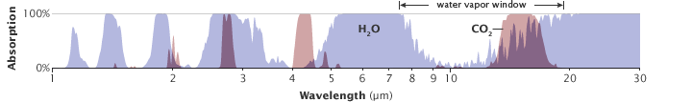

Figure 1. Overlapping absorbance peaks of CO2 (red) and H2O (blue). From NASA (https://earthobservatory.nasa.gov/features/EnergyBalance/page7.php).

Consequently, it is common to correct for the effect of water vapor using models (Liu et al., 2017) or creating a conversion factor through empirical data (Smethie et al., 1985; Wall 2014). For example, Wall (2014) empirically created the following calibration curves to correct for water vapor specifically for the K30 sensor (Senseair, Sweden):

$K{30}_{CO2} =\left[(K{30}_{raw}-K{30}_{H2O}\right)*m_{dry}]+b$ Equation 8

$K{30}_{H2O}=m_{H2O}*V_{H2O}+b_{H2O}$ Equation 9

$V_{H2O}=6*{10}^{-5}(T^{3})+ 5*{10}^{-4}(T^{2})+0.055(T)+0.571$ Equation 10

In these equations, $K{30}_{CO2}$ is the corrected CO2 reading, is the reading before correction, is the amount of the reading due to the presence of water vapor, $m_{dry}$ and b are the slope and intercept of the dry calibration curve. In Equation 9, $m_{H2O}$ and $b_{H2O}$ are the slope and intercept of the K30 reading vs vapor pressure curve linear regression, which is generated empirically by measuring the response of the K30 to a N2 gas stream with a relative humidity ~100% at varying temperatures. $V_{H2O}$ is the vapor pressure of water, and $T$ is the temperature in °C (Equation 10).

Readings of pCO2 are also affected by temperature, which Takahashi et al. (1993) estimated to be a 0.0423 % effect per oC. However, in her study, Wall (2014) found that the readings of the K30 were not significantly affected from 1-20 oC.

### *1.4 Calculating CO2 flux using ΔpCO2*

Flux is defined as the rate of flow of a property across or through a surface of unit area. Air-water CO2 flux (F, mol*m-2*d-1) can be calculated using the following equation from Wanninkhof (1992):

$F=(k_{w}*K_{H}*ΔpCO_{2})$ Equation 11

Where $k_{w}$ is the gas transfer velocity (m/hr), $K_{H}$ is the solubility of CO2 (mol*m-3*atm-1) which depends on pressure, temperature, and salinity, and is (pCO2water – pCO2air) in atm. This equation assumes that the majority of flux is due to diffusion. A positive F value indicates CO2 outgassing from the water into the air. In the open ocean, kw is primarily dependent on wind speeds (Ho et al., 2011; Wanninkhof, 1992). However, in more variable environments like estuaries, kw is affected by wind speed, tidal currents, and bottom stress (Raymond et al., 2000; Zappa et al., 2007). Jiang et al. (2008) adapted the gas transfer velocity formula from Wanninkhof (1992) for use in estuaries to account for that variability:

$k_{w}=\left(0.314v^{2}-0.436v+3.99\right)*\sqrt{\frac{{Sc}_{SST}}{660}}$ Equation 12

Where *v* is the wind speed (m/s) typically measured 10 m above the sea surface and ${Sc}_{SST}$ is the Schmidt number at that sea surface temperature in °C (SST).

### *1.5 Alternative Approaches for* CO2 *Flux Estimating*

Multiple alternative approaches for estimating CO2 flux exist, including the eddy covariance (Fc) and chamber techniques (see, e.g., Rosentreter (2022) and references therein for technical details). Eddy covariance is often used in terrestrial environments to estimate ecosystem respiration and has also been used on many ship studies in the ocean to examine CO2 fluxes in the open ocean (Miller et al., 2010; Prytherch et al., 2010). The equipment required typically uses an ultrasonic anemometer and an infrared gas analyzer to track the flow of CO2/H2O molecules at very high frequency, whereafter flux, *F*, is calculated:

$F= \overline{ρ_{a}}*(\overline{w'C'}$) Equation 13

Where $\overline{ρ_{a}}$ is the ensemble average of dry air density, $\overline{w'}$ is the mean expected deviation of the vertical component of wind velocity, and $\overline{C'}$ is the mean expected deviation of the dry air mixing ratio of CO2. Eddy covariance assumes that the flux is fully turbulent, and the vertical transport of molecules is done by eddies in the atmosphere/water column.

The chamber technique is another common approach for estimating CO2 fluxes, where a floating enclosure of a known volume is placed on the air–sea interface. The headspace of the enclosure is sampled for pCO2 (*g*) right as it is placed onto the surface, and then after a known period of time, the headspace is sampled again, typically with an NDIR sensor. Using the volume of the chamber, its temperature and pressure, and the time that has passed, CO2 flux can be estimated by the following equation according to Frankignoulle (1988):

$F= \frac{ΔpCO_{2}}{Δt}*\frac{V}{RTS}$ Equation 14

Where $ΔpCO_{2}/Δt$ is the slope of the (presumably linear) change in CO2 concentration during an elapsed time ( $Δt$), V is the volume of the chamber, R is the gas constant, T is temperature, and S is the surface area of sea covered by the chamber. The two measurements are used to obtain a ΔpCO2 value, which is used to calculate flux according to Equation 14.

These three CO2 flux estimation techniques—the ∆pCO2 approach that we employ and the eddy covariance and chamber approaches—all have unique advantages and disadvantages. For instance, the eddy covariance technique relies on direct measurements only (rather than empirically derived terms, as is the case for ∆pCO2), but field studies have demonstrated that it is accurate only when averaged over longer time periods (i.e., > 30 minutes) and that resulting flux values correspond to areas with relatively large footprints (1-10 km) (Miller et al., 2010; Rosentreter, 2022). Consequently, it is most useful when attempting to measure CO2 flux over large swaths of spatially uniform environments. The traditional chamber technique requires substantial operator interaction in order to periodically vent it to the atmosphere (Frankignoulle, 1988); however, there are modern chambers that automate the venting process, such as the EOSfd (Eosense, Dartmouth, Nova Scotia). Additionally, chambers frequently alter the environment they are designed to observe, therefore adding uncertainty to the result (Rosentreter et al., 2017). For instance, a chamber could meaningfully impact turbulence which can be a key driver of gas exchange. The ∆pCO2 method is dependent on the knowledge of $k_{w}$ which, as described above, is determined via empirical relationships and is therefore prone to uncertainties in those relationships (Whitmore et al., 2021). However, it can be used in smaller footprints and may require less operator effort. Finally, the components used for a ∆pCO2 system can be less expensive than those used in known eddy covariance systems; for these reasons, we selected the ∆pCO2 approach and describe it in further detail below.

## **Section 2**. Current Technology

### *2.1 Low-cost* CO2 *sensors (<$300)*

With the increasing need for CO2 monitoring (including for indoor air quality studies), there has been a recent focus on developing low-cost sensors to measure CO2. While there are other methods to sensing CO2 (e.g., electrolytes and semiconductors), NDIR sensing has proven to be one of the most stable and versatile types (Fine et al., 2010; Mandayo et al., 2011). For instance, semiconductor-based sensors are used primarily in higher CO2 concentrations and electrolyte sensors have a shorter lifespan, while NDIR sensors can last over a decade with proper maintenance (Yasuda et al., 2012).

A popular NDIR sensor used in several studies is the K30 from Senseair, Sweden that can measure 0–10,000 µatm, costs $99, and has an accuracy of ±30 µatm ±3% of the measured values (MV). In a study by Yasuda et al. (2012), four different small NDIR sensors were compared for accuracy, response time, and drift. They found that the relative mean square error could be reduced to 4% for the K30 sensor with calibration, which was the lowest of the devices tested. However, Yasuda et al. also found that the dust-filter on the K30 may inhibit the rate of diffusion to the sampling cell, suggesting its removal may be beneficial if other filters are already present.

Other popular low-cost CO2 sensors include the CozIR ($129, ± 50 ppm), ExplorIR ($129, ± 70 ppm), and SprintIR ($179, ± 300 ppm) from Gas Sensing Solutions in the UK. Senseair also manufactures the S8 Mini ($99, ±200 ppm), K33 ($299, ±3% of MV), and the Sunrise 1% ($229, ±30 ppm). Telaire manufactures the T6713, which costs $92.29 with an accuracy of ±2% MV, and Sensiron manufactures the SCD40 at $29.70 with an accuracy of ± 50 ppm ± 5% MV). When compared to the listed NDIR sensors, the K30 has one of the lowest reported errors within this price range.

### *2.2* CO2 *flux sensors*

CO2 flux sensors that are commercially available for oceanic use can cost several tens of thousands of dollars. For example, the CO2 -Pro (Pro-Oceanus, Canada) uses alternating pCO2 measurements of the water column and the air to calculate flux and costs $32,000. Other CO2 flux sensors like the InfraRedGas Analyzer LI6262 (LICOR, Nebraska, USA) measure flux using eddy covariance and also cost around $21,500. The sonic anemometer needed for eddy covariance measurements costs an additional $5,000–$15,000. Several groups have developed low-cost CO2 flux systems using affordable components; however, it seems the majority of these systems are for use in terrestrial environments and not commercially available (Brändle et al., 2022; Curcoll et al., 2022; Helm et al., 2021). Other researchers have increased accessibility through making open-source and user-friendly software; the Flux Puppy is an app created to make calculating CO2 fluxes with the chamber method more practical and efficient. However, the Flux Puppy can only communicate with some LICOR Analyzers, which can cost $3,000-$6,000. Therefore, there is a still an unmet need for an accurate, low-cost, and user-friendly sensor in the CO2 flux space.

### *2.3 Low-cost pCO2 systems*

Many researchers have developed low-cost pCO2 systems for specific environments using sensors like the ones described in section 2.1. The K30 sensor was successfully mounted onto an uncrewed aerial system to measure pCO2 in inaccessible areas (Azevedo, 2020) and used to develop an autonomous pCO2 /CO2 flux system for estuarine environments using semi-permeable membrane (Wall, 2014). The SIPCO2 was developed as another aquatic pCO2 system using the K30, which used a water bubbler to achieve equilibrium (Hunt et al., 2017). In all low-cost systems, a balance between cost, response time, and accuracy is needed to optimize the product, which is commonly discussed as the greatest challenge by the authors of these systems. For example, the device by Wall (2014) is a pCO2 system with a response time of 17.9 minutes, whereas some pCO2 systems have a response time as low as 3 seconds (Hales et al., 2004). Wall discusses the implications of a longer response time on data from an estuarine system which are extremely variable in nature; the pCO2 measurements may be delayed and “smeared” and not accurately represent the flux. The response time of semi-permeable membranes is restricted primarily by the rate of diffusion across the membrane.

### *2.4 Gas permeability*

Gas permeability is the property of a material that allows gas to pass through to obtain equilibrium. A material with a high permeability would have a high rate of diffusion and vice versa. Gas permeability depends on the pore-size of the material and the specific gas in question. Smaller gas molecules diffuse quicker.

Many semi-permeable membranes are porous to gases but hydrophobic so that they can be used in aquatic applications. In CO2 monitoring applications, thin silicone or PTFE film is often used due to their high gas permeability. However, thin silicon sheets can cost $145 for 1 sq ft while PTFE tape only costs $12 for 7.2 sq ft (McMaster-Carr). Therefore, for low-cost applications, PTFE may be the better choice. Expanded PTFE (ePTFE) is gaining popularity for its CO2 permeability and hydrophobic quality; for example, specific ePTFE sleeves have been manufactured by an outside company to specifically fit onto Vaisala CO2 sensors (International Polymer Engineering, Arizona, USA). These sleeves have since been used to measure aquatic pCO2 in several environments and have an empirically derived diffusivity of 0.08 ± 0.01 cm2/s (Johnson et al., 2009; Whitmore et al., 2021).

### *2.5 Response time and τ*

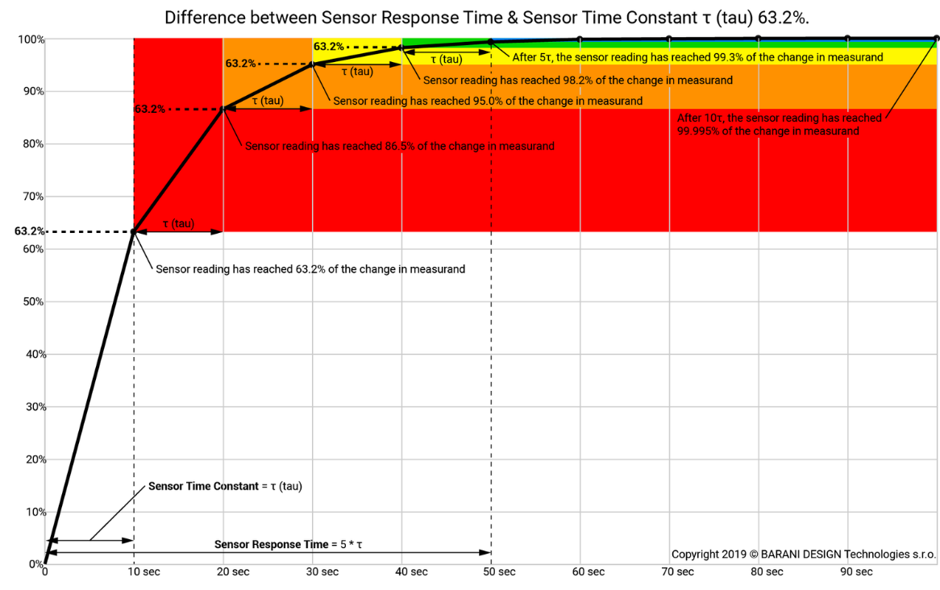

Figure 2. A visual representation of sensor response time and the sensor time constant. Created by Barani Design. <https://www.baranidesign.com/faq-articles/2019/5/6/difference-between-sensor-response-time-and-sensor-time-constant-tau>

For a system with a first-order response curve, τ is the sensor time constant, and it is the amount of time a sensor requires to read 63.2% of a step change between two concentrations (i.e., if the sensor was moved from a concentration of 0 ppm to 1,000 ppm, τ would be the amount of time it took the sensor to go from a reading of 0 to a reading of 632 ppm). The sensor’s total response time is often described as 5τ, or how long it takes the sensor to read 99.3% of the total concentration. With each sample taken at a τ interval, the sample is 63.2% closer to the true concentration than it was before. The above figure from Barani Designs illustrates this concept (Figure 2). In order to be able to monitor CO2 at the highest possible frequency and/or optimize battery life by turning the sensor off between readings, a short response time is desirable.

## **Section 3.** Seagrass

### *3.1 Seagrass basics*

Seagrass is a marine angiosperm whose blades are interconnected to each other through shared rhizome structures (Larkum et al., 2006). Seagrass is unique, as it is the only plant in the marine environment with a true root system, a vascular system, and undergoes underwater pollination. It can absorb nutrients through their roots, which are then transported throughout the plant via their lacunae and vascular system. In addition to sexual reproduction, they also reproduce by asexual clonal growth.

*3.2 Seagrass in NC*

There are approximately 72 species of seagrass globally, but three species of seagrass dominate the coast in NC: the temperate *Zostera marina* (eelgrass), the subtropical *Halodule wrightii* (shoalgrass), and the weedy *Ruppia maritima* (widgeon grass) (Bartenfelder et al., 2022). In fact, NC has the largest recorded polyhaline seagrass system on the east coast of the US (Field et al., 2021). Approximately 40,000 ha of seagrass is found in the temperate waters of NC (NCDEQ 2016).

Seagrass is able to thrive in NC due to the presence of the barrier islands, behind which lay calm sounds where seagrass is protected from the surf. Additionally, the convergence of the Gulf Stream and the Labrador Current contribute to the moderate climate that further supports the two species of seagrass (Figure 3). *H. wrightii* prefers the warmer waters of the Gulf Stream, while *Z. marina* prefers the cooler waters from the Labrador current (Figure 3). Therefore, *H. wrightii* biomass typically peaks in the late summer when water temperature is highest, and *Z. marina* biomass peaks in late spring (Bartenfelder et al., 2022).

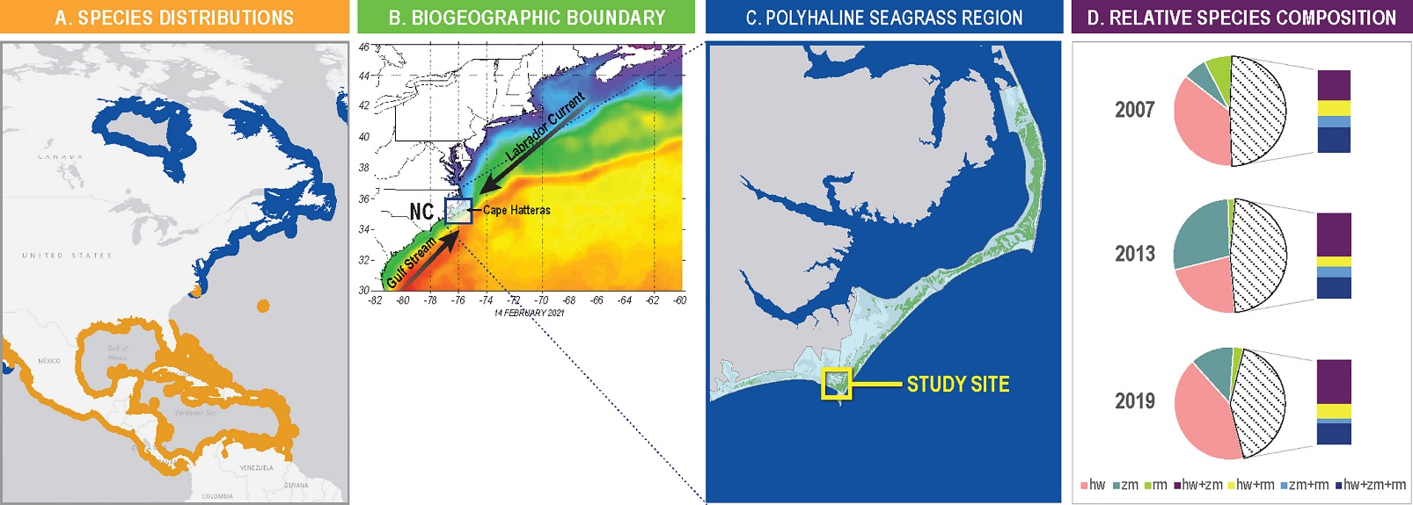

Figure 3. A: The habitat distribution of H. wrightii (orange) and Z. marina (blue). B: The convergence of the Labrador Current and Gulf Stream. Figure adapted from Bartenfelder et al., (2022).

### *3.3 Importance*

Seagrass meadows are one of the most coastal marine important habitats globally and in NC, both environmentally and economically. In NC, it is estimated that losing 50% of the state’s seagrass in the next decade would result in the loss of $88.75 million (Sutherland et al., 2021). Currently, NC is losing seagrass at a rate of 1.7% per year, which increases with land development (Field et al., 2021). Additionally, seagrass provides crucial ecosystem services such as nutrient removal, fish habitat, sustenance for sea turtles and other grazers, wave energy dissipation, and carbon sequestration (Potouroglou et al., 2017; Sutherland et al., 2021).

However, coastal development may alter how effectively seagrasses are able to perform these ecosystem services, especially carbon sequestration. Seagrass is especially vulnerable to land development due to increases in turbidity, runoff, and phytoplankton blooms which often outcompete it for nutrients and light (Moorman et al., 2017). Additionally, increasing water temperatures are causing major losses of *Z. marina* in NC (Bartenfelder et al., 2022; Wilson & Lotze, 2019). In areas where wetlands become developed, organic carbon stored in sediments is released, and seagrass is less likely to survive due to the disturbance, leading to further sediment destabilization (Li et al., 2007). In fact, one study found that sites that lost their seagrasses due to development also lost the equivalent of about 90 years of carbon deposition in about a third of the time (Marbà et al., 2015).

### *3.4 Carbon cycling*

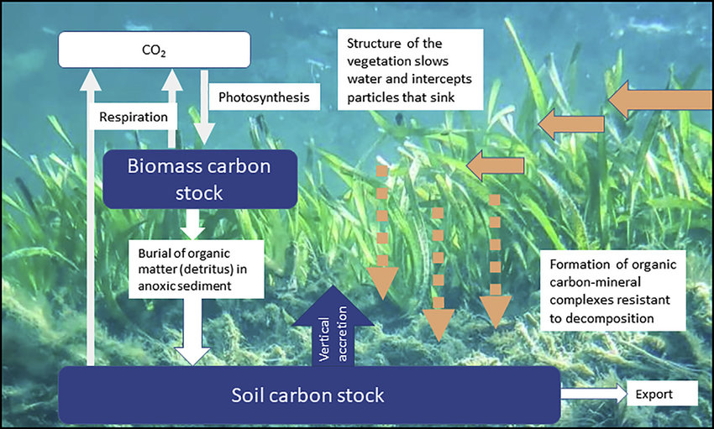

Figure 4. A model of the movement of carbon within seagrass meadows. (Lovelock http://dx.doi.org/10.1016/j.oneear.2020.07.010 )

Seagrass removes inorganic carbon from surrounding waters when it performs photosynthesis and incorporates it into organic biomass, potentially resulting in a local reduction in pCO2. However, competing processes, such as the formation of carbonates, can result in the production of CO2, complicating the issue (Fakhraee et al., 2022). Additionally, CO2 may be released by respiration, remain in the organic carbon pool as seagrass biomass, or move through the food web if the seagrass is consumed by herbivores. As the seagrass or other organisms die and sink to the benthos, their detritus can become incorporated into the sediment as organic matter which may be later exported to the deep ocean (Lovelock & Reef, 2020). Additionally, seagrass traps particulate organic matter floating through the water by interrupting water flow, adding to the accretion (Figure 4).

It is estimated that seagrass is responsible for 10% of the organic carbon stored by the entire ocean, also known as “blue carbon” (Fourqurean et al., 2012; Herr & Landis, 2016). The loss of seagrass globally may release up to 299 Tg C/year if present rates of decline continue (Fourqurean et al., 2012). This is approximately equivalent to the total carbon emissions of Italy in 2018, demonstrating their significance (IEA, 2023). In just the Albemarle-Pamlico Sound in NC, seagrass sequesters an estimated 164,000 tons of carbon each year (Sutherland et al., 2021).

# **CHAPTER ONE: DEVELOPMENT OF THE SEACOW**

Based on the community need for high-quality, low-cost CO2 flux instruments, especially for use in highly variable aquatic environments, our objective for Chapter One is the following:

## **Objective**

1. Design a low-cost ΔpCO2 system, termed the SEACOW (**S**ensor for the **E**xchange of **A**tmospheric **CO**2 with **W**ater), whose values can be used to estimate CO2 flux in marine environments.

## **Methods**

### *1.1 Initial Design*

Multiple individuals have contributed to the design and refinement of the ∆pCO2 system described here. A previous undergraduate working with Dr. Phil Bresnahan, Michael Tydings, in our research group began prototyping the instrument based off Bresnahan’s design. The design for a ∆pCO2 measurement using a low-cost NDIR CO2 sensor is novel, but prior studies (e.g., Hunt et al. (2017) and Wall (2014)) have described pCO2 instrumentation (notably, lacking the air–water ∆ mode) using low-cost sensors, and others (e.g., Sabine et al. (2020), Nicholson et al. (2018) , and Sutton et al. (2014)) have built ∆pCO2  systems using more expensive sensors and, frequently, onboard standards for autonomous calibration.

The focus of the sensor development portion of my research has been to operationalize and characterize our novel sensor prototype. The prototype that I began working with laid the groundwork of mechanical and electrical design but did not accurately measure ∆pCO2 and substantial improvements were needed. For example, several elements of the design needed to be changed, the response time and accuracy needed to be characterized, the code refined, the electronics secured, and the flow of air made airtight.

### *1.2 K30 & K30 Housing*

The K30 10,000 µatm CO2 Sensor (Senseair, Sweden) is a NDIR sensor that costs $99. It is the central component to our system and measures pCO2 to an accuracy of ±30 µatm ±3% and a precision of ±20 µatm ±1% of the reading, which can be improved with calibration. Its manual says that it measures XCO2; however, it was empirically determined by Wall (2014) that the K30 measures pCO2, which our group concurred with after preliminary testing. In order to determine a direct response to pCO2 rather than XCO2, I flooded a tube with gas of 500 ppm CO2 and monitored the readings of the K30 placed inside as I increased the internal pressure by gradually pushing in the end cap of the tube. Additionally, the K30 has an automatic baseline correction (ABC) algorithm that helps to deter long-term drift by recording the lowest reading over a 7.5-day interval and using it to correct the readings by assuming that the lowest reading would correspond to fresh air with a value of 400 ppm, a faulty and harmful assumption in these highly dynamic coastal and estuarine environments. Because our K30 will be measuring pCO2 in the water as well as the air, the ABC algorithm was turned off prior to deployments using methods described in the K30 Modbus manual. We incorporated the K30 into our system by using its universal asynchronous receiver-transmitter (UART) capabilities for serial communication.

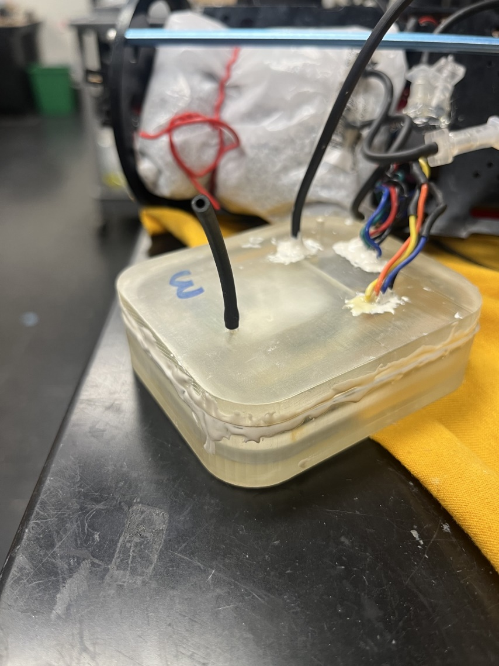Our system is a dual closed loop system (see following section for a description of air flow), so our K30 needed to be in an air-tight housing to ensure there was no contamination of the air sample. Furthermore, unlike many other gas analyzers, the K30 does not have a single inlet/single outlet and instead relies on diffusion across its top surface. Accordingly, a custom design was required. Using the AutoDesk CAD program and our Form 3+ 3D printer (Formlabs, Massachusetts USA), several prototypes were created to enclose the sensor in the smallest volume possible, while trying to minimize possible air pockets. Making the K30 housing air-tight proved to be a challenge especially because we still needed our wire connections to be accessible. However, we used a custom housing with an O-ring seal (designed by undergraduate researcher, whom I mentored, Dan Portelli). Then, we sealed the spaces around each wire with marine epoxy to ensure there were no leakages (Figure 5). In later experiments, it was determined that there was still leakage despite the O-ring, so we further sealed the housing with marine epoxy.

Figure 5. The 3D-printed K30 housing with an O-ring. The wire holes are and top are sealed with marine epoxy. The BME 280 and K30 sensors are housed inside. It is 8.7 cm x 7.5 cm x 2.7 cm.

We used 24 inches of nafion tubing (CO2Meter, Florida USA) coiled in a plastic bag full of ~162 g of Drierite (DRIERITE Co. LTD, Ohio USA) to dry the air before entering the K30 housing in order to reduce likelihood of condensation on the K30 optics and water vapor affecting the CO2 readings.

We also included a BME280 Sensor (integrated circuit by Bosch-Sensortec; available on breakout board from Adafruit, NYC USA: https://www.adafruit.com/product/2652) inside the K30 housing to measure temperature, pressure, and humidity within the enclosure. The sensor is $15 and reads humidity with ±3% accuracy, barometric pressure with ±1 hPa absolute accuracy, and temperature with ±1.0°C accuracy. We used the humidity and pressure measurements to post-process our pCO2 measurements to correct for water vapor and pressure changes, which is detailed in Chapter 2.

### *1.3 Flow of air inside the SEACOW*

After testing the effectiveness of silicone tubing, various plumber’s tapes, and other membranes as our diffusion barrier to exchange CO2 with the environment, I chose two versions of expanded-PTFE from International Polymer Engineering in Arizona, USA (See Chapter 2 for more details). For the airside of the SEACOW, I created a planar diffusion exchanger made with 2” wide expanded-PTFE membrane. For the water side, I coiled 50 cm of expanded-PTFE tubing with an inner diameter of 1.85-2.00 mm in a 3D-printed holder to act as the diffusion barrier for that side. We chose to use tubing for the water side instead of a planar design, as, in initial testing, bubbles got stuck on the planar surface underwater. CO2 diffuses into the PTFE membrane, enters the air stream, flows through the solenoid valves, the nafion tubing and Drierite, a 35-micron filter, the pump, and then into the K30 to return to the solenoid valves (Figure 6).

All other tubing used in the system is non-permeable Viton tubing (ID 0.158 cm x OD 0.318 cm). The diaphragm gas pump (KNF, Germany) has a brushless DC motor, which allows it to function at input voltages lower than its specified 6 V. At a full 6 V, it runs at a rate of 0.4 l/m. Our pump receives 3.3 V and therefore runs at approximately 0.15 - 0.2 l/m. The 35-micron inline filter (Lee Co, Connecticut USA) removes fine particles from the air flow before entering the K30 housing. The solenoid valves (Lee Co, Connecticut USA) only need one pulse of current to switch polarity and direction of airflow.

Figure 6. The plumbing diagram using ePTFE as a planar exchanger for the air side and ePTFE tubing for the water side.

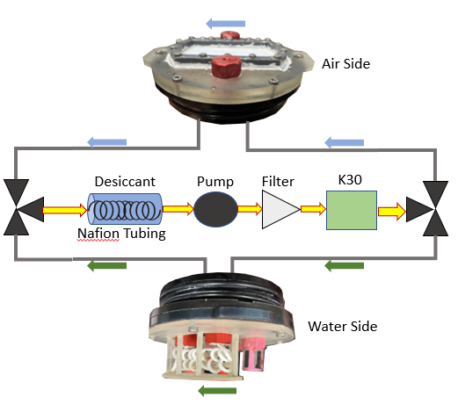

### *1.4 Electronics*

We built the ΔpCO2 instrument using several different off-the-shelf electrical components soldered onto a breadboard. An overview of each component and its purpose is given below the following block diagram (Figure 7):

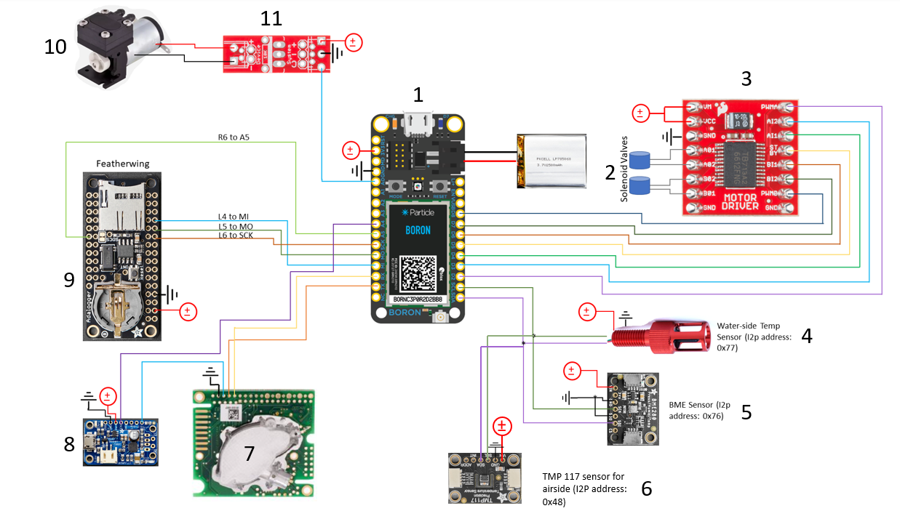

Figure 7. Electrical block diagram for the components making up the SEACOW.

1. Particle Boron: the microcontroller that carries out the commands from the script. The Boron has an onboard cellular modem with LTE capabilities, allowing it to upload data directly to a google spreadsheet during its deployments. It is powered using a rechargeable 3.7 V Li-ion battery.
2. Lee Co 3-way Solenoid valves: controls the flow of air so we can switch between measuring the air side and the water side of the instrument.
3. Sparkfun Motordriver: controls the solenoid valves and allows us to turn them on and off for enough time to trigger the electromagnetic response that switches the direction of air flow.
4. Blue Robotics temperature sensor: measures the water temperature.
5. Adafruit BME 280 Sensor: measures temperature, pressure, and humidity. It’s installed in the housing of the K30, so we can use these values to correct the reported pCO2 values.
6. Adafruit TMP 117 Sensors: measures the temperature on the air side of the instrument.
7. Senseair K30 CO2 sensor: the NDIR sensor that is measuring pCO2.
8. Adafruit Powerboost: converts the 3.3 V output of the Boron to a 5 V output, which is the minimum voltage required for the K30 to function. It also turns on and off the K30 during sleeping periods.
9. Adafruit Adalogger Featherwing: the datalogger that stores data onto its SD card.
10. Diaphragm gas pump: moves the air throughout the closed-loop system.
11. Sparkfun MOSFET power control kit: allows us to turn the pump on and off in between samples.

### *1.5 Script*

The Boron microcontroller is manufactured by Particle (California, USA) for ~$65 and can be programmed using Particle’s Web Integrated Development Environment (IDE) or their extension on Visual Studio Code (VS Code). Since VS Code can handle the development of larger scripts than the Web IDE and is considered the professional development environment, we chose to develop our code there. The code, which I refined and maintained and has contributions from Bresnahan and Tydings, uploads data directly to a Google spreadsheet while the instrument is deployed, sleeps when it is not in use to conserve battery, and successfully switches between measuring pCO2 on the air-side and water-side.

### *1.6 Outer Enclosure*

The entire system, including all its electrical components, was secured onto an electronics tray with zip ties that slides into a 4” diameter tube. All components of the outer enclosure are manufactured by Blue Robotics (California, USA). Blue Robotics sells an aluminum watertight tube and an acrylic tube for the outer enclosure, but we found that they blocked the cellular connection to the microcontroller and trapped significant heat, respectively. Therefore, we used schedule-80 4” PVC pipe and machined the inside to be perfectly circular and polished to be O-ring smooth (600 grit emery cloth). On both sides of the PVC tube is a watertight end cap secured by an O-ring flange.

For the air side top (Figure 8), we 3D-printed an end cap that has a serpentine channel carved into it and is compatible with the existing O-ring flange from Blue Robotics after being polished to be O-ring smooth. The serpentine channel connects to the impermeable tubing through barbs printed on the underside and thus is part of the air flow. The 80-micron thick ePTFE membrane is placed on top of the serpentine channel and secured in place using a custom 3D-printed retainer with 14 4-40 machine screws. The retainer has gaps in the side to allow any rain or waves to roll off the membrane during deployments and a copper mesh to protect the membrane and decrease biofouling. CO2 permeates through the ePTFE and becomes incorporated into the flow of air. I placed the TMP117 sensor (Adafruit, NYC USA) in a 3D-printed housing that fits onto a Blue Robotics cable penetrator to measure air-temperature (Figure 8). The TMP117 is sealed inside using marine epoxy except for a small portion where the actual sensing component of the TMP117 is exposed, which was covered in thermally conductive epoxy in order to improve thermal response time. The TMP117 sensor was used instead of another Blue Robotics temperature sensor because two Blue Robotics temperature sensors would have the same I2C address and therefore not be compatible to be run at the same time.

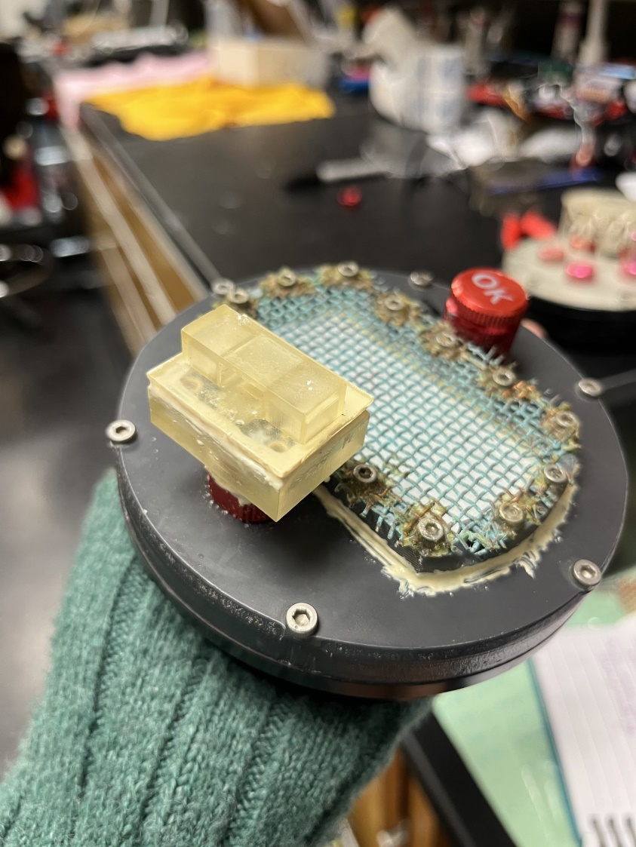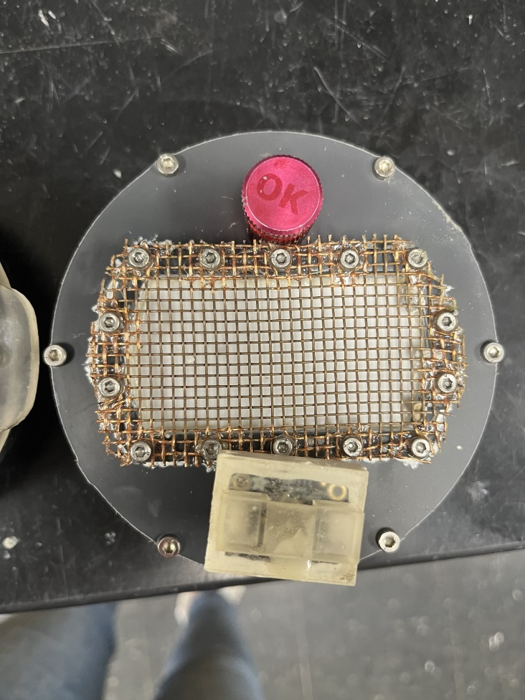

Figure . Air side planar membrane with the TMP117 sensor encased in a 3D printed housing.

For the water side cap, we 3D-printed a tubing holder that fits on top of the aluminum end cap from Blue Robotics. The 1.85-2.00 mm inner diameter ePTFE tubing (IPE, Arizona USA) was coiled around the 3D-printed tubing holder and connected to two cable penetrators potted with barbed tubing and sealed with marine epoxy, which connects to the rest of the airstream (Figure 9). We placed a temperature sensor (I2C Fast Response, Blue Robotics) on this side to measure water temperature. Copper mesh was wrapped around the entirety of the 3D printed tubing holder to protect the tubing and decrease biofouling.

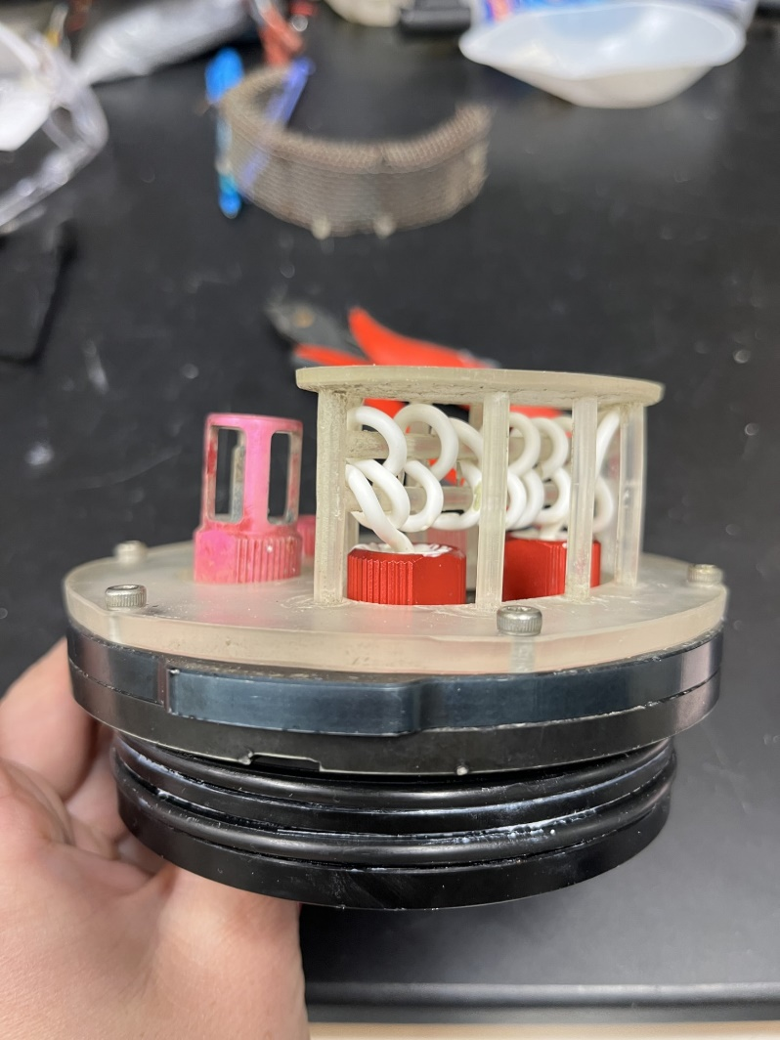

Figure . Water side cap with coiled ePTFE tubing and Blue Robotics temperature sensor.

## **Results**

After many design iterations, I built 3 more SEACOWs for a total of four, which is the main result of this chapter. Each SEACOW is capable of measuring and logging atmospheric and aquatic pCO2 and publishing data to a google sheet through cellular capabilities. In addition to the creation of several SEACOWs, I created and maintained two Github repositories and a Sharepoint folder documenting aspects of the SEACOW, which is linked below:

* Public Github Repository: <https://github.com/COAST-Lab/SEACOW_Public>
  + This repository does not include the final firmware version for the SEACOW because our group currently has a provisional patent on the instrument.

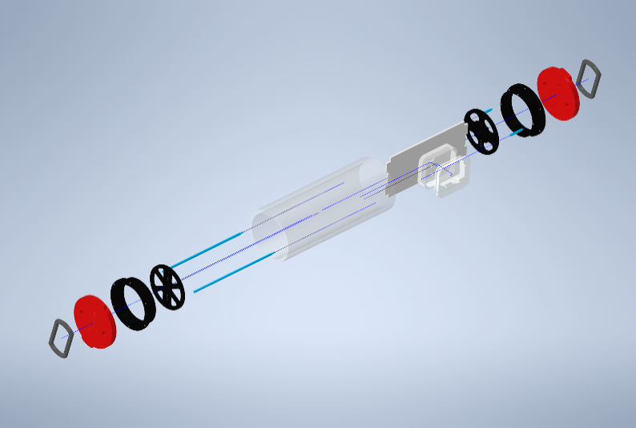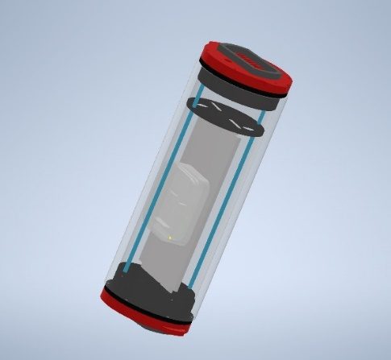

Figure . An exploded diagram of the housing of the SEACOW. The retainer is secured onto the end cap, which screws into the O-ring flange. Inside of the 4 in diameter tubing is the electronics tray for securing the breadboard and K30 housing.

# **CHAPTER TWO: CHARACTERIZING THE SEACOW**

## **Objective**:

1. Conduct laboratory and field investigations to rigorously characterize the specifications of the sensor (e.g., response time, accuracy, power budget, deployment length)

## **Methods:**

### *2.1 Power Budget*

As defined in the firmware script, the SEACOW goes through 5 states: delay before starting, measuring water side, measuring air side, publishing the data to the cloud, and sleeping. If cellular capabilities are turned off, then it goes through all the states except for publishing data to the cloud.

While each state ran, the current draw of the system was measured with a multimeter and used to calculate a theoretical run time based on how long each state runs for using the following formula:

$\frac{W*h}{\sum_{j=1}{I_{j}*V*f_{j}}}$ Equation 15

In the above formula, *W*h* is the total energy available (units of watt-hours) of the battery, $\sum_{j=1}{I_{j}*V*f_{j}}$ is the sum of the power used in each state ($I_{j}*V$) times the fraction of time that the system is in that state (f_j). I is the current measured during a state and *V* is the voltage of the battery. We typically use 3.7 V, 10,050 mAh batteries, which equates to 37.2 Wh.

Publish state does not have a set duration because it depends on how quickly the device can connect to the cloud, but it will not spend more than 70 seconds trying to connect to the cloud. Therefore, I used the upper limit of 70 seconds for this state’s calculation. Using the assumption that the water side runs for 30 min, the air side runs for 8 min, and the instrument sleeps for 22 minutes, the SEACOW has an average power draw of around 185 mW and should theoretically run for approximately 13 days on one battery when not affected by temperature or humidity issues. In practice, we observed that the battery only lasted ~6 days, which suggests that the battery depletion is not linear, or that power draw is underestimated. Many autonomous oceanographic sensors use substantially larger battery packs or solar panels; in future versions of the SEACOW, both should be investigated as potential improvements.

### *2.2 Drierite Budget*

To estimate how long the small plastic bag of ~ 162 g of Drierite lasts during deployments before it can absorb no more moisture, the percentage of exhausted indicator Drierite was visually estimated for the time frame of its deployment. Then, using the logged data, the total time spent pumping is obtained. I solve for *x* in the following equation to estimate how long it would take to exhaust 100% of the Drierite:

$\frac{\% exhausted}{Time spent pumping}= \frac{100}{x}$ Equation 16

We repeat this evaluation several times to take the average of *x* and estimate one bag of Drierite to last about 68 hours of active pumping time, which is about a 5-day deployment. In summary, the Drierite budget is currently the time-limiting factor.

### *2.3 Air side accuracy*

To assess the accuracy and to create a dry calibration curve for the K30 sensors, we ran it against a LI-850 in all air-side experiments, which has an accuracy of within 1.5% of the true concentration. Prior to use, we zeroed the LI-850 with pure N2 gas and then spanned it to 2000 ppm using a mixture of N2 and CO2 gas (Size 200 Industrial Grade, Airgas, CT USA) according to LICOR’s [User-Calibration guide](https://www.licor.com/env/support/LI-850/topics/maintenance.html). The CO2 concentration was controlled using mass flow controllers (Alicat, Arizona USA). The N2 and CO2 gas were mixed in a sealed plastic container before being received by the LI-850 (Figure 11). In my calculations to obtain certain CO2 concentrations, I assume CO2 is an ideal gas despite potential CO2-CO2 molecule interactions, as these interactions have a negligible impact on the detected concentration (~1 µatm)(Takahashi et al., 1997). These calculations are detailed in the appendix.

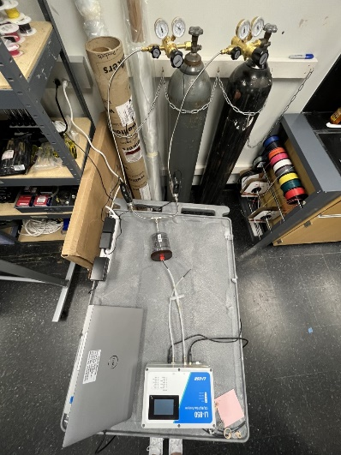

Figure 11. Set up for LI-850 Calibration. Gas flows into the sealed plastic container to mix before being read by the LI-850.

After calibrating the LI-850, I compared the measurements of the SEACOWs and the LI-850 at several different CO2 concentrations for what I refer to as stepwise gas experiments. N2 and CO2 gas flowed into an acrylic box (729 in3) which was sealed using marine epoxy and has a removable top, so the inside was accessible (Figure 12). An AC 115 V fan (Mechatronics, Washington USA) was fixed to the inside of the box to ensure even mixing. Cable penetrators were installed into the wall of the acrylic box, which were used to connect the input and outputs of the LI-850 and the SEACOWs. During the experiments, the output of the LICOR was left unconnected to the box so the air would be pumped out by the LI-850 and pressure maintained. I started by connecting the end caps to the potted penetrators to mimic the closed loop system experiencing different levels of CO2. I started at 0 ppm and increased the concentration to 1500 ppm in approximately 250 ppm increments every 25 min. I performed several variations of this experiment with different tubing thicknesses, PTFE film types, and end cap designs to optimize our design. I repeated this process with the water side tubing as well to ensure they performed the same as the planar ePTFE.

I used the equilibrated readings from each SEACOW and the LI-850 at each step of the experiment to make a linear regression between them, which I used as a dry calibration curve to correct the SEACOW values.

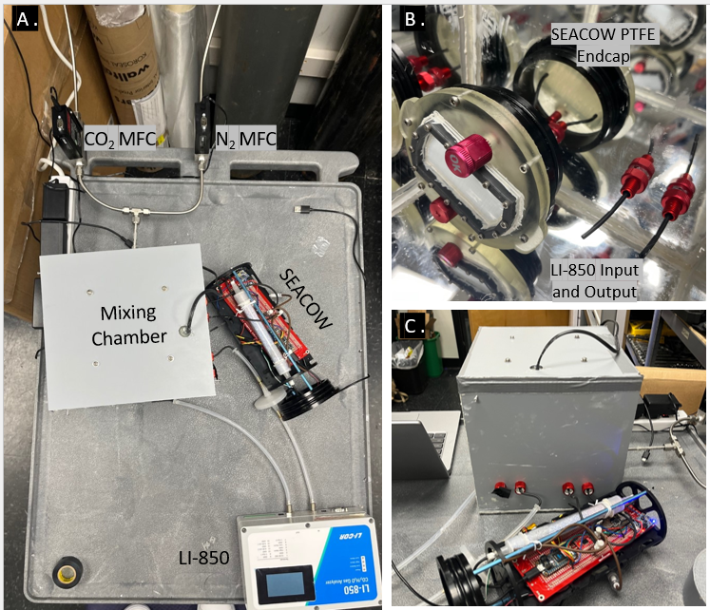

Figure 12. Set up for the gas experiments. Gas flows from the mass flow controllers (MFCs) into the mixing chamber, where it is read by the SEACOW and LI-850 and then pumped out by the internal pump in the LI-850.

### *2.4 Response time*

### *2.4.1 Air side*

The LICOR-850 has a T90, or time it takes to detect 90% of the maximum concentration, response time of < 3.5 seconds. Therefore, the LI-850 was used to indicate when the box reached the goal concentration and was able to compare its readings to our system in order to assess the SEACOW’s response time. To estimate the air-side response time of the SEACOW, I flooded the acrylic box with 1500 ppm CO2 and waited until both the SEACOW and LI-850 stabilized. At a recorded time, I removed the top of the box and flooded the box with ambient air, facilitated by a fan. The time it took for each instrument to stabilize to the influx of ambient air was recorded, which provides an approximation of 5τ for the air side.

### *2.4.2 Water side*

To estimate the 5τ time for the water side, a gas mixture of 1000 ppm CO2 was bubbled into 2-liters of deionized water for 24 hours to produce water with elevated pCO2. A stir plate was used to ensure even mixing. Additionally, the gas mixture was bubbled first through a flask of deionized water prior to reaching the 2-liters to humidify the gas stream and reduce evaporation. We placed the SEACOW into the 2-liters of high pCO2 water and recorded the amount of time it took for the SEACOW to completely equilibrate as an estimate of the 5τ time.

### *2.5 Temperature*

Because our instrument is going to be exposed to the field, we want to estimate what temperatures the SEACOW can handle before malfunctioning. By looking at the working specifications of each of the components of the SEACOW and choosing the most conservative lowest and highest point, we were able to estimate an approximate range of 5-40 °C (41°F - 104° F), which is consistent with what I observed during field deployments (e.g., occasional instrument shut-offs at elevated temperatures during mid-summer deployments of the self-heating housings).

### *2.6 Humidity and Pressure Correction*

We used the humidity, pressure, and temperature measurements from the BME280 sensor inside the K30 housing, as well as the water/air side temperatures, to correct our K30 readings according to methods by Wall (2014) and updated for our lower humidity air stream:

$K{30}_{CO2} =\left[(K{30}_{raw}-K{30}_{H2O}\right)*m_{dry}]+b$ Equation

Equation

Equation

In these equations, is the corrected CO2 reading, is the reading before correction, is the amount of the reading due to the presence of water vapor, $m_{dry}$ and *b* are the slope and intercept of the dry calibration curve (as described in the above *section 1.3*), $m_{H2O}$ and $b_{H2O}$ are the slope and intercept of the K30 reading vs vapor pressure curve linear regression, *H* is the relative humidity inside the K30 housing, $V_{H2O}$ is the vapor pressure of water, and $T$ is the water temperature in °C.

To obtain $m_{H2O}$ and $b_{H2O}$ first, I placed a flask of deionized water inside a water bath (6200 R20, Fisher Scientific, MA, USA) through which I bubbled pure N2 gas to achieve a 100% humidity airstream which fed into the K30 housing. The temperature of the water was varied from 18°C - 24°C to simulate a reasonable temperature range for the coast of North Carolina and then calculated vapor pressure according to Equation 19. Once the vapor pressure values were calculated, I made a linear relationship between vapor pressure and the K30 readings (Figure 13), which gave me $m_{H2O}$ and $b_{H2O}$. Note that no CO2 gas was used in this step, so the entire response is due to H2O.

This vapor pressure was calculated at a 100% humidity stream, but the inside of the K30 housing only gets to 40-50% humidity during deployments because of the Nafion tubing and Drierite. Therefore, we multiply $K{30}_{H2O}$ by the proportion of the logged humidity to account for the fact that 100% humidity is not reached during actual deployments.

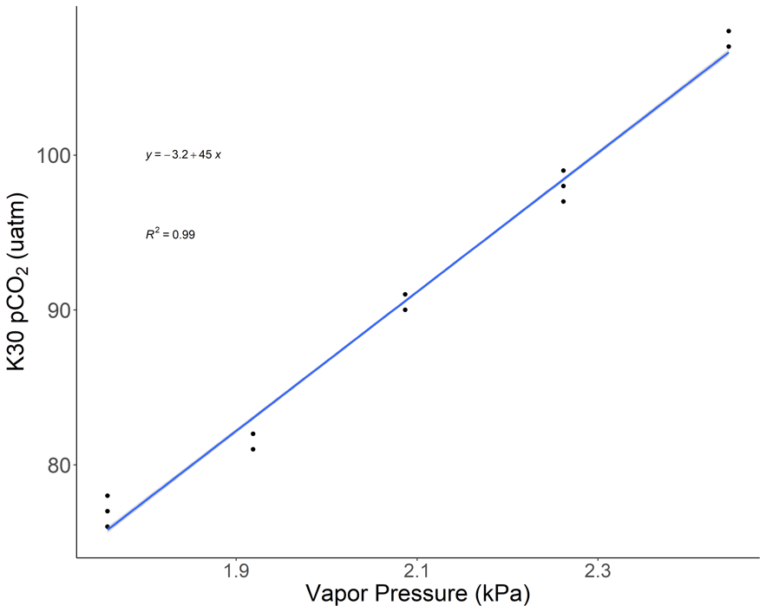

Figure . Linear relationship between vapor pressure and K30 pCO2 readings: y = -3.2 +45x.

**Results**:

### *Air side accuracy*

During the stepwise gas experiments, we determined that the K30, and thus our SEACOW, reported stabilized measurements to within ~2% of the LI-850’s readings after the dry calibration curve was applied (Figure 14; Table 1). The SEACOW values at 0 µatm had considerably larger variation, suggesting that SEACOW readings may stray at more extreme concentrations. Water side accuracy is described in Chapter 3. The root mean square error for SEACOW1, 3, and 4 compared to the LICOR after calibration is 5.09, 12.13, 3.48, respectively.

Figure . Stepwise gas experiment of all four SEACOWs vs the LI-850 before and after the dry calibration curve was applied. LI-850 XCO2 measurements were converted to pCO2 for comparison. SEACOW2 became inoperable and thus is excluded from these plots.

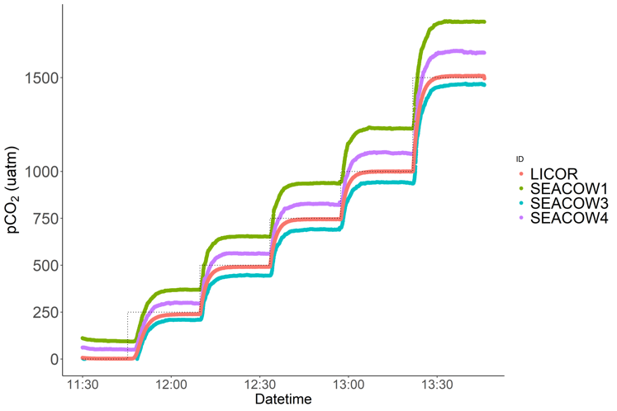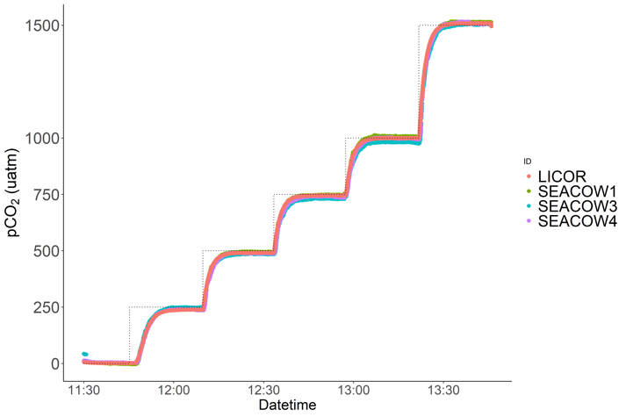

Table . Summary of results from air-side dry calibration stepwise gas experiment. Pre refers to values that have not had the calibration curve applied, while post refers to those that have. SEACOW2 became inoperable and thus was excluded from this table.

|  |  |  |  |  |  |  |  |
| --- | --- | --- | --- | --- | --- | --- | --- |
| **Set Point** | **SEACOW1 Average Reading** (µatm) | | **SEACOW3 Average Reading** (µatm) | | **SEACOW4 Average Reading** (µatm) | | **LI-850 Average Reading** (µatm) |
|  | *Pre* | *Post* | *Pre* | *Post* | *Pre* | *Post* |  |
| 0 | 95 | -2 | -15 | 25 | 51 | 4 | 1.43 |
| 250 | 369 | 242 | 208 | 248 | 298 | 238 | 238.36 |
| 500 | 653 | 495 | 445 | 485 | 561 | 488 | 490.85 |
| 750 | 937 | 748 | 690 | 730 | 825 | 739 | 744.68 |
| 1000 | 1228 | 1007 | 940 | 980 | 1097 | 997 | 999.26 |
| 1500 | 1798 | 1513 | 1464 | 1503 | 1633 | 1506 | 1508.30 |
| Dry Calibration Curves:  SEACOW1: *K30corrected = 0.89(K30raw) – 86*  SEACOW3: *K30corrected = 1(K30raw) + 40*  SEACOW4: *K30corrected = 0.95(K30raw) - 45* | | | | | | | |

*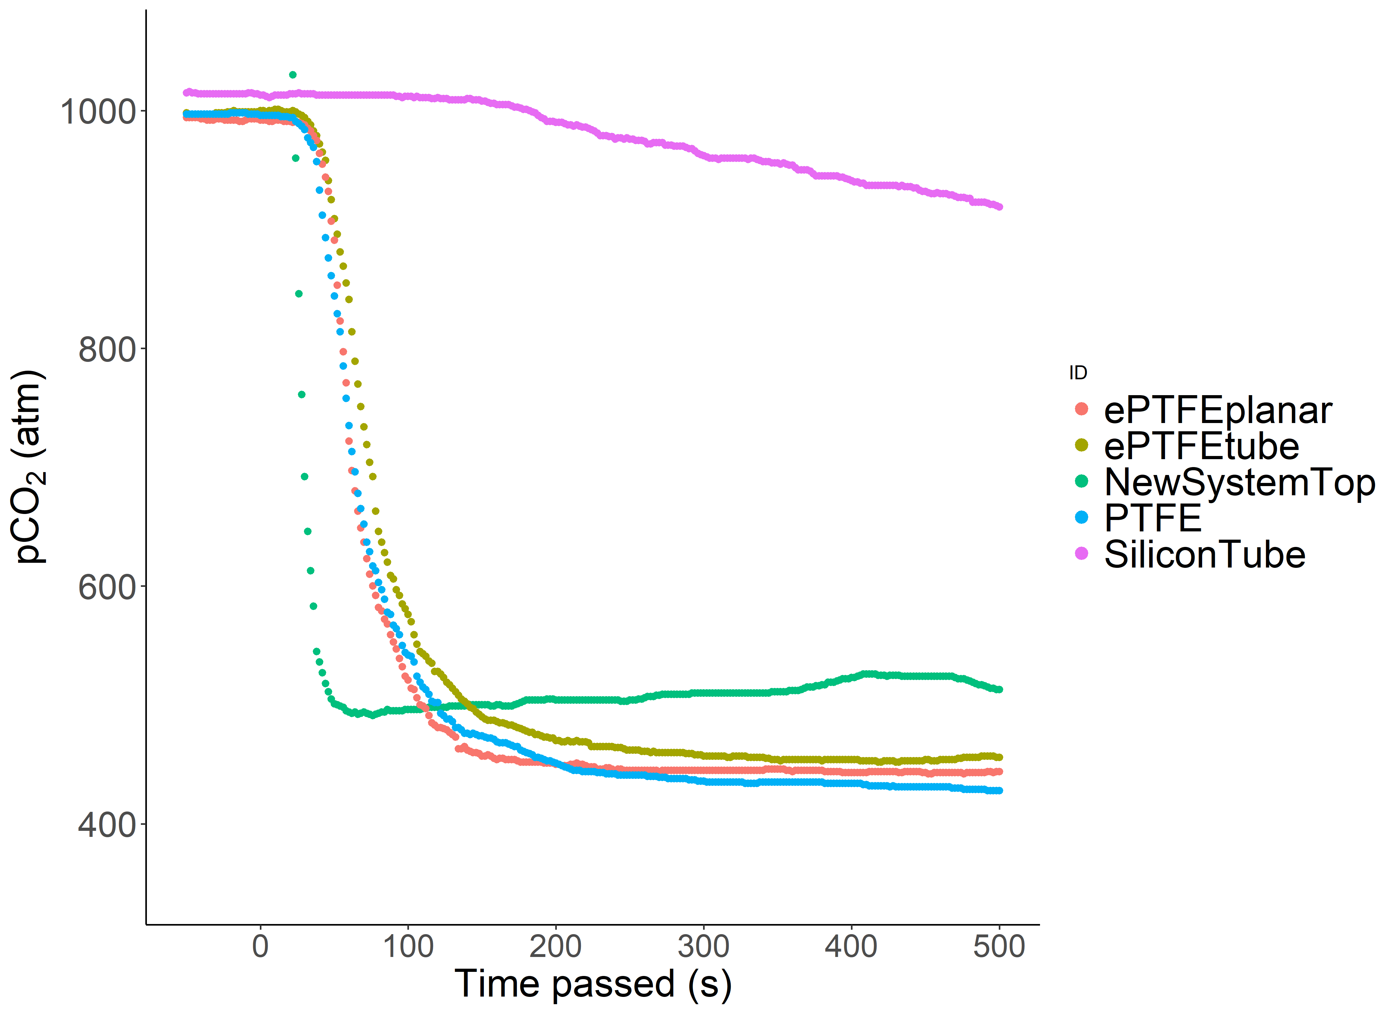**Air-side response time* Using the air-side response time methods described above in *Section 2.4.1*, I tested the response time of several different materials to decide which to use as the diffusion membrane (Figure 15). After deciding on ePTFE and building several SEACOWs, I characterized the response for each one (Figure 16).

Figure . Response of several materials to a sudden change of CO2 concentration at time 0.

We use an LICOR LI-850 (a well-validated, community-accepted instrument) as our comparison for accuracy and response time studies, which I refer to as the LICOR. It is important to note that the LICOR is making direct atmospheric CO2 measurements whereas the SEACOW requires first the permeation of CO2 from the atmosphere into the sample loop and subsequently its diffusion into the K30. The T90 response time of the LICOR is listed as < 3.5 seconds. Therefore, we considered the LICOR response to be effectively immediate in comparison to the SEACOW. After equilibrating the instruments to 1000 ppm using the acrylic box set up, I recorded how fast each instrument responded to opening the lid of the acrylic box and blowing ambient air into the box using a fan, which happened at 0 seconds. The averaged 99.3% 5τ response time for the SEACOW is 5.7 minutes (Figure 16).

Figure 16. Response of the SEACOWs to a sudden change of CO2 concentration. SEACOW2 became inoperable and is thus excluded from this plot.

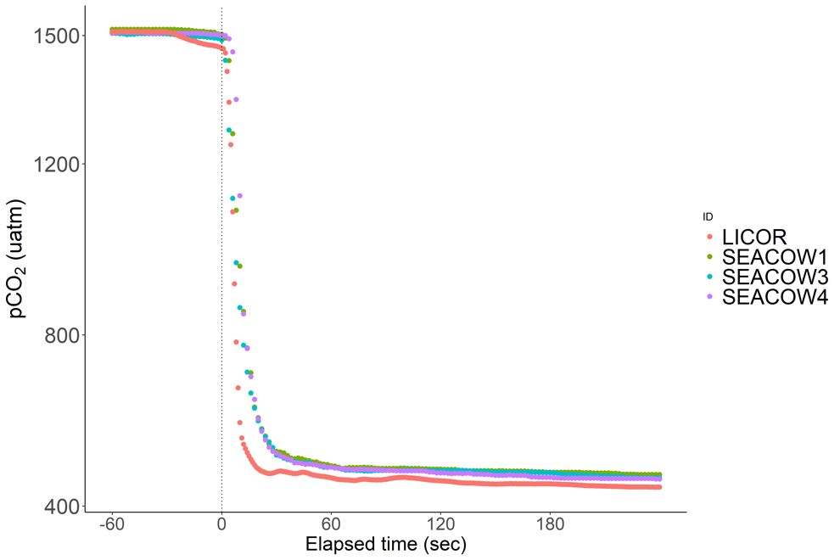

### *Water-side response time*

After 24 hours of bubbling, the SEACOW was placed into the 2-liters of water at time 0 and recorded the amount of time it took for the SEACOW to completely equilibrate as an estimate of the 5τ time, which is approximately 29.6 minutes (Figure 17).

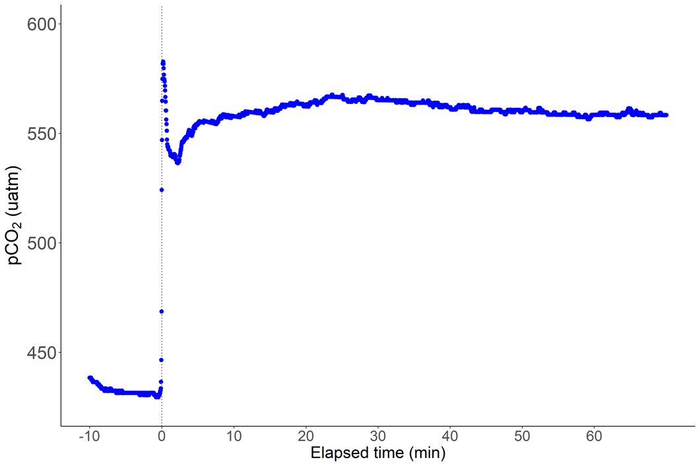

Figure . Water-side response time for the SEACOW. The “shakiness” of the response curve is likely due to the imperfect nature of bubbling water with CO2 gas in an open environment to achieve elevated pCO2 levels.

# **CHAPTER THREE: ASSESSING THE CAPABILITY OF THE SEACOW THROUGH SEAGRASS DEPLOYMENTS**

## **Objectives**

1. Conduct field testing in the *Zostera marina* and *Halodule wrightii* meadows in Intracoastal Waterway in Topsail, NC, to assess the SEACOWs’ field deployment capabilities.
2. Design and conduct tank experiments to assess the ability of the SEACOWs to capture the diel cycling of pCO2 due to seagrass productivity, as well as their aquatic pCO2 accuracy.

## **Methods:**

### *Field deployment site information*

From June 2, 2023 to June 21, 2023, four SEACOWs were deployed in the Intracoastal Waterway in Topsail Island, NC. We chose this site for its accessibility, its abundance of seagrass, and because there was a YSI EXO2 (Xylem, Ohio, USA) deployed at this site continuously (courtesy of Coastal Plant Ecology Lab, UNCW). During this time of year, the *Z. marina* is prevalent but about to enter its senescence phase, and *H. wrightii* is increasing in biomass (Bartenfelder et al., 2022). The averaged water conditions recorded by the YSI every 5 days of its deployment are summarized in the following table:

Table . Averaged water quality conditions in the intracoastal waterway at Topsail, NC, as recorded by a YSI EXO2.

|  |  |  |  |  |
| --- | --- | --- | --- | --- |
| Averaged time frame | Temperature ℃ | Salinity psu | pH | DO mg/L |
| June 2nd – 7th | 23.232 | 33.65 | 7.87 | 7.00 |
| June 8th – 13th | 25.093 | 34.29 | 7.88 | 6.84 |
| June 14th – 19th | 26.234 | 35.56 | 7.93 | 6.80 |
| June 20th – 21st | 27.592 | 35.67 | 7.89 | 6.57 |

*1.2 Field deployment scheme*

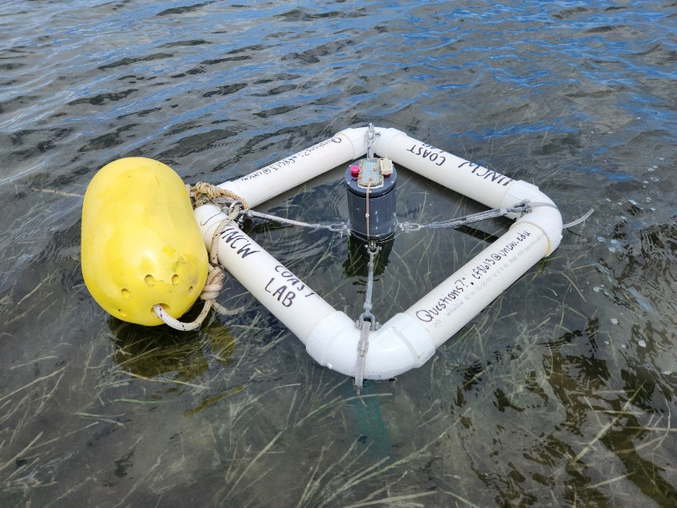

Figure . Buoy design to hold the SEACOWs during field deployments. A yellow buoy was added for visibility.

The SEACOWs were deployed in custom-built buoys made from 3” PVC pipe, turnbuckles, and hose clamps, was anchored to a cinder block using ~7’ of rope (Figure 18). The buoy was designed to withstand wakes from boats, have enough slack to stay anchored during tidal fluctuations, and hold the SEACOW at the sea surface. Wire legs were added to the buoys so that the SEACOWs waterside membrane would not touch the benthos and get covered with mud during especially low tides.

We deployed the SEACOWs across four ~20 m2 areas (Figure 19). These four sections contained: no seagrass, very patchy seagrass, medium patchy seagrass, and fully dense seagrass, as determined by a visual assessment with a quadrat. We deployed across a gradient of seagrass patchiness to assess variability in ∆pCO2 as a function of patchiness. We deployed the SEACOWs at approximately the same water depth in each location, roughly 50-70 cm at low tide.

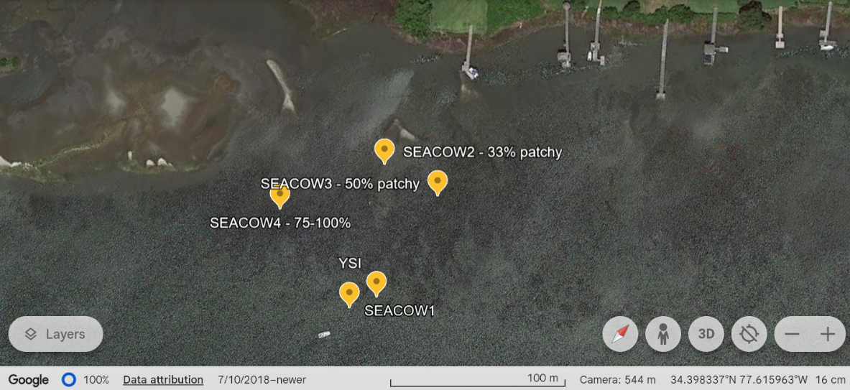

Figure . Deployment locations of the SEACOWs at the Topsail, NC seagrass meadow. SEACOW1 was deployed in an area with no seagrass.

The SEACOWs were serviced about every 4-5 days; I switched out their batteries, changed out the used Drierite, downloaded the data, and rinsed off biofouling from the membranes with DI water.

### *1.3 Tank experiment set up*

After analyzing data from the field experiments and making some design adjustments to the SEACOWs, my tank experiment was set up. I collected ~0.65 m2 of *H. wrightii* from the Topsail site on September 25, 2023, under UNCW CMS Collection DMF Permit #2037980 by coring the area to preserve the root system of the seagrass. Immediately following the coring, the seagrass and its sediment were placed into 4 rectangular plastic containers and placed into coolers, which were filled with seawater to avoid desiccation. Additionally, we collected ~15 gallons of sediment from a seagrass-free area. Coolers and sediment were transported back to our laboratory. Upon arriving at the lab, each plastic container was filled with sediment to make sure the seagrass was securely planted, and sand was sprinkled on top of the muddy sediment to decrease resuspension. Sand was collected from the Crystal Pier at Wrightsville Beach, NC. Each plastic container containing seagrass was placed into a 25-gal tank, which I filled with filtered seawater (< 10 µm) to decrease the amount of biologically active material (i.e., living heterotrophs or autotrophs which could influence CO2 and O2) being introduced to the tank. For my control tank, I filled 4 more empty plastic containers with the collected sediment and sand and placed them in a different 25-gal tank, which I also filled with filtered seawater (Figure 20). Each tank was outfitted with a hanging power filter (Qmax 90GPH), without the filter, to gently mix the water and a glass tank heater set to 22 ℃. The thermal tolerance for *H. wrightii* is 20-30 ℃, so our tanks were kept in an acceptable temperature for the seagrass (Mazzotti et al., 2007). Because my tanks were closed-loop systems and prone to evaporation, ~4 liters of deionized water was added every 2-3 days to ensure the salinity of the tanks stayed consistently at 34-36 psu. *H. wrightii* tolerates a wide range of salinities, from 25-45 psu with no changes in growth rate; therefore, my seagrass was kept at an optimal range similar to where it was collected from (Mazzotti et al., 2007). Additionally, four Finnex Planted+ aquarium lights were put on each tank to ensure sufficient lighting and set on a timer to be on from about 6 am – 6 pm every day.

SEACOWs 1, 3, and 4 were used for the tank experiment, as SEACOW 2’s dry calibration curve showed had a y-intercept of over 100, which was over the recommended upper limit for adjustment (Wall, 2014). Therefore, it was partially dismantled and used for replacement parts. SEACOW 3 and 4 were placed in the tank with seagrass, and SEACOW1 was placed in the control tank. SEACOW1 and SEACOW3 have the same ePTFE tubing size (1.85 mm inner diameter), so they were separated in order to have a stronger comparison between the two tanks. By having SEACOW3 and 4 together in the same conditions, the intent was to compare their readings to get an idea of instrument precision. Note that the differing ePTFE tubing inner diameters (e.g., SEACOW4 has a diameter of 2.0 mm) is an artifact of supply availability and was not an intentional variable. Additionally, we added a dissolved oxygen logger (miniDOT, PME, CA, USA) to each tank alongside the SEACOWs.

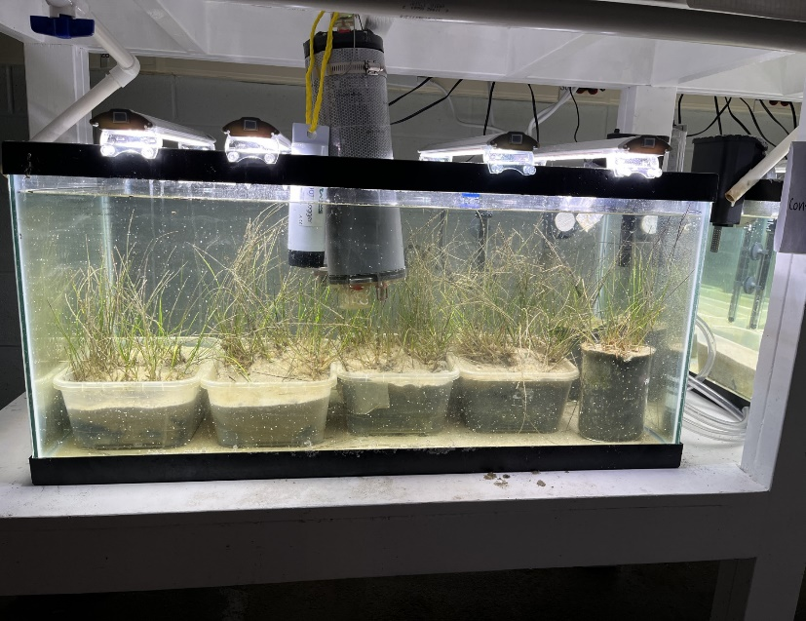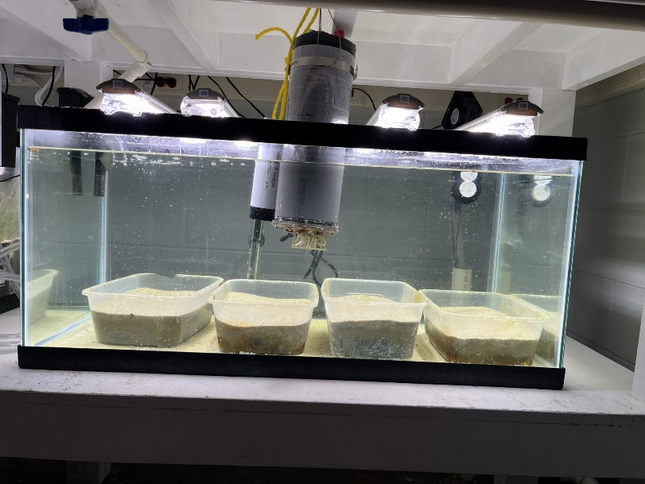

Figure . Tank set up. SEACOW1 was placed in the control tank, and SEACOWs 3 and 4 were in the seagrass tank.

### *1.4 Water samples and processing*

To assess how accurate the SEACOW’s aquatic pCO2 values are, I collected water samples during the tank experiment to analyze total alkalinity (TA) and dissolved inorganic carbon (DIC). Because TA and DIC are two of the four master variables of the marine inorganic carbon system, they can be used to estimate the other two, including pCO2. To begin discrete sample collection, I pre-poisoned 20 mL glass scintillation vials with 10 µL of saturated mercuric chloride to prevent any biologic activity in the water samples that would affect the DIC or TA. To collect the water sample, I took the plunger out of a 60 mL syringe, rinsed both parts in the water I was sampling several times, and gently dipped it underwater to fill. I added the plunger while it was underwater to avoid any great pressure changes that could affect the TA/DIC. After lifting it out of the water, I added a tubing attachment to the syringe, dispensed 10 mL to rinse the inside of the tubing, and then put the tubing inside of the 20 mL scintillation bottle and slowly started filling the vial to the very top for the DIC sample. The tubing attachment allows the water to gently flow into the vial to reduce gas exchange which would alter the DIC (and pCO2) value. Keeping the same water in the syringe, I then switched the tubing attachment for an Acrodisc GxF/Glass 25 mm filter, dispensed 10 mL to rinse the filter and then filled the vial to the top for the TA sample.

I repeated this process two more times with different syringes at each sampling site, so each sample was taken in triplicate. Immediately following sampling, parafilm was wrapped clockwise around the tops of the vials to prevent evaporation. Salinity and temperature measurements were taken with a Castaway CTD (SonTek, California, USA). To analyze the TA samples, I used an 848 Titrino Plus autotitrator (Metrohm, Switzerland). For the DIC samples, I used the inorganic carbon package on the Total Organic Carbon Analyzer (Shimadzu, Japan).

After obtaining TA and DIC values, I used the seacarb package in RStudio to calculate pCO2 values, using the temperature and salinity data taken at the time of collection (Gattuso et al., 2021). I compared those pCO2 values to the equilibrated water pCO2 values from the SEACOW.

## **Results:**

### *Lessons from field deployments*

While laboratory deployments of the SEACOWs were promising, the experience with them while collecting field data showed that there are many improvements to be made if the SEACOW is to be a field instrument, which are listed below:

* Theoretically, a 3.7V, 10,000 mAh battery should last the SEACOW almost 13 days. However, in the field, we were only able to get 48-hour deployments due to two main issues: a coding error and the use of lithium-based batteries. The coding error was fixed. However, the Li-ion batteries I used are sensitive to increased humidity, which can dramatically decrease the life of the battery. Therefore, opening the instrument up in the intracoastal waterway to change out the batteries in the already humid North Carolina weather caused damage to the batteries, which was evident by their swelling. So, it is my recommendation that batteries are installed in an air-conditioned room, drying packets are placed inside the container, and a waterproof button and USB port is installed externally to have the ability to turn on and off the instrument and flash new firmware without having to open up the instrument each time in the field. Additionally, the SEACOW currently logs data to an SD card, so efforts should be made to design a way to download the data through the USB connected to the Particle Boron, so data can be downloaded in the field. Solar panels could be installed to be able to charge the instrument and lengthen deployments without having to open the instrument outside to change out batteries.
* The current buoy design does not have a place for a potential solar panel to be installed. Therefore, it is my recommendation that if a solar panel is to be installed, a new buoy design is implemented. I believe the SOFAR spotter buoy could be used to inspire the shape of this buoy because it could house solar panels as well as providing a very secure structure to withstand waves (SOFAR Ocean Technologies, California, USA).
* The drying agent is currently the biggest limiting factor for the SEACOW. Currently, the SEACOW exhausts about ~162 grams of Drierite for a 5-day deployment. This number could be greatly reduced if the amount of time spent pumping on the water side was reduced. This could involve changing the diffusion membrane for the water side, adding a physical mixing mechanism to increase the rate of diffusion of CO2, or implementing a new way of reaching water-side equilibrium through methods such as those in (Hunt et al., 2017).
* The SEACOW can take its equilibrated values for the air and water side and publish them through cellular LTE to a Google sheet. However, the schedule-80 PVC pipe used to make the SEACOW housing was too thick for the cellular antenna to work consistently. Therefore, it is my recommendation that an external cellular antenna is installed for the SEACOW for future field deployments.
* Depending on how often the SEACOW is serviced in the field, biofouling of the ePTFE water-side membranes may present a problem. During my field deployments, I observed that the water side membrane biofouled the worst in the densest parts of the seagrass meadows. Moderate biofouling was present after 8 days of being deployed; however, it was easily cleaned off by spraying deionized water on the membrane. For longer deployments without servicing, copper could be wrapped around the ePTFE tubing itself or a physical stirring mechanism introduced to cause disturbance. Including external water pumps has also been shown to reduce the rate of biofouling-induced changes to similar sensor measurements (Bresnahan Jr et al., 2014).

*Tank deployments*

SEACOW 1 – Control Tank

SEACOW 4 – Seagrass Tank

Figure . Raw time series data from the tank experiments. The yellow shaded areas represent when the lights were turned on.

Figure 21 shows the raw time series pCO2 data. SEACOW3 was in the tank with SEACOW4 but was excluded from Figures 21-24 due to reporting unreliable data, likely caused by an internal air leak. Next, I took the average of the last 5 and 3 minutes of data for each water side and air side cycle, respectively, which are the equilibrated end points. I plotted the equilibrated end points from each cycle alongside the dissolved oxygen (DO) for each tank A graph with blue and purple lines
(Figure 22).

SEACOW 4 – Seagrass Tank

SEACOW 1 – Control Tank

Figure . Equilibrated pCO2 end points plotted for the air and water side for the seagrass tank. Dissolved oxygen (DO) is plotted on the second y-axis in purple.

The two tanks both showed evidence of diel pCO2 cycling, likely due to the presence of a microbial community in the sediment; however, it was much more consistent and exaggerated in the tank with seagrass (Figure 21 & Figure 22). The lack of cycling in the DO readings in Tank 1 also suggest that there was no consistent photosynthesis happening, presumably due to the lack of seagrass (Figure 22). The sudden drop in water pCO2 values on October 16th can be likely attributed to a large addition of deionized water to the tanks that day to maintain optimum salinity for the seagrass. For Figure 23, I took the difference between the averaged equilibrated water-side values and the air-side values to produce ∆pCO2 values.

Figure . ∆pCO2 values for SEACOW1 and 4, which were in the control tank and seagrass tank, respectively.

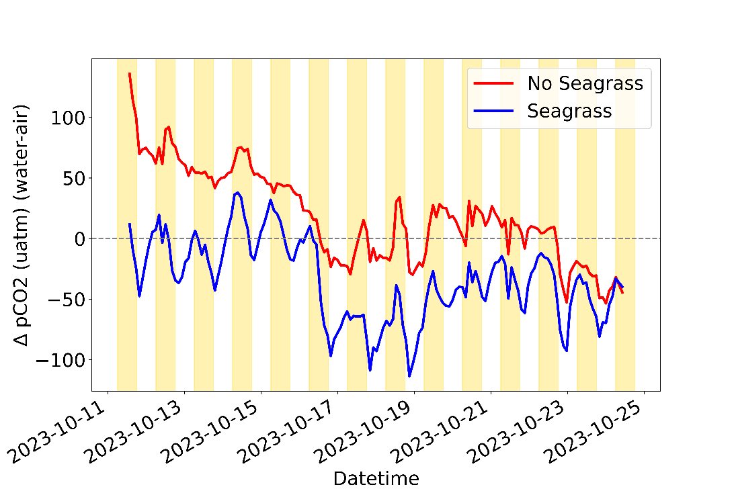

### *Aquatic pCO2 accuracy*

I took each DIC and TA water sample in triplicate and used seacarb in RStudio to calculate the pCO2 for each set of DIC/TA values (Gattuso et al., 2021). Then for each set of calculated pCO2 values, I took the average and standard deviation. In Figure 24, the average pCO2 value for each triplicate sample is plotted on top of the SEACOW’s averaged equilibrated water-side values. The error bars represent the standard deviation of the pCO2 values. It is possible that the significant variation is due to limitations with instrumentation, such as using an organic carbon analyzer (Shimadzu) to assess inorganic carbon, or user sampling error. On average, the pCO2 water samples were 44 µatm and 53 µatm different from SEACOW1 and SEACOW4’s final readings at the closest time point, respectively.

Figure . pCO2 water sample results plotted on top of the equilibrated water side points for SEACOW1 and 4. SEACOW1 was in the control tank, and SEACOW4 was in the seagrass tank. The error bars are the standard deviation of the pCO2 values.

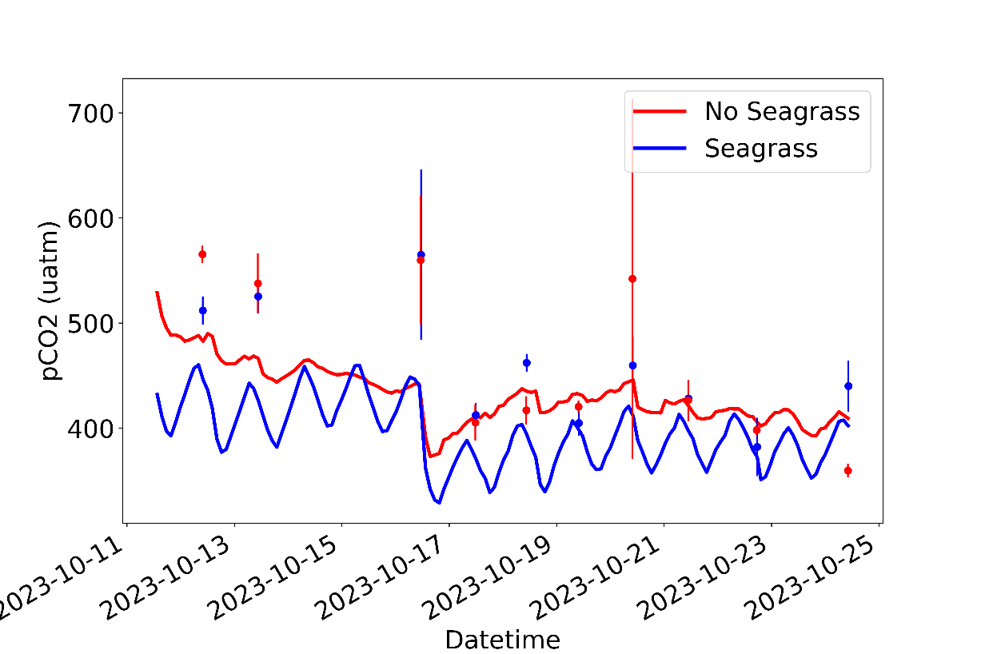

### *CO2 Flux*

The CO2 flux for the tanks was estimated using the ∆pCO2 values from the SEACOWs and Equation 11. Because the tanks were inside and not subject to any wind, which is the primary parameter to estimating kw, the gas transfer velocity, I used 1 cm/hr as a constant for kw. Typically, this would be insufficient for calculating reliable flux values, but I am calculating CO2 flux only for proof-of-concept in this application. Furthermore, I estimated KH, the solubility of CO2, by using Table A2 from Wanninkhof (1992) to calculate KH based on the recorded temperature and salinity measurements made throughout their deployment. The results are plotted below in Figure 25. It tightly resembles the ∆pCO2 plot (Figure 23), which is a product of using a constant kw value, causing ∆pCO2 to be the primary driver of flux in this example.

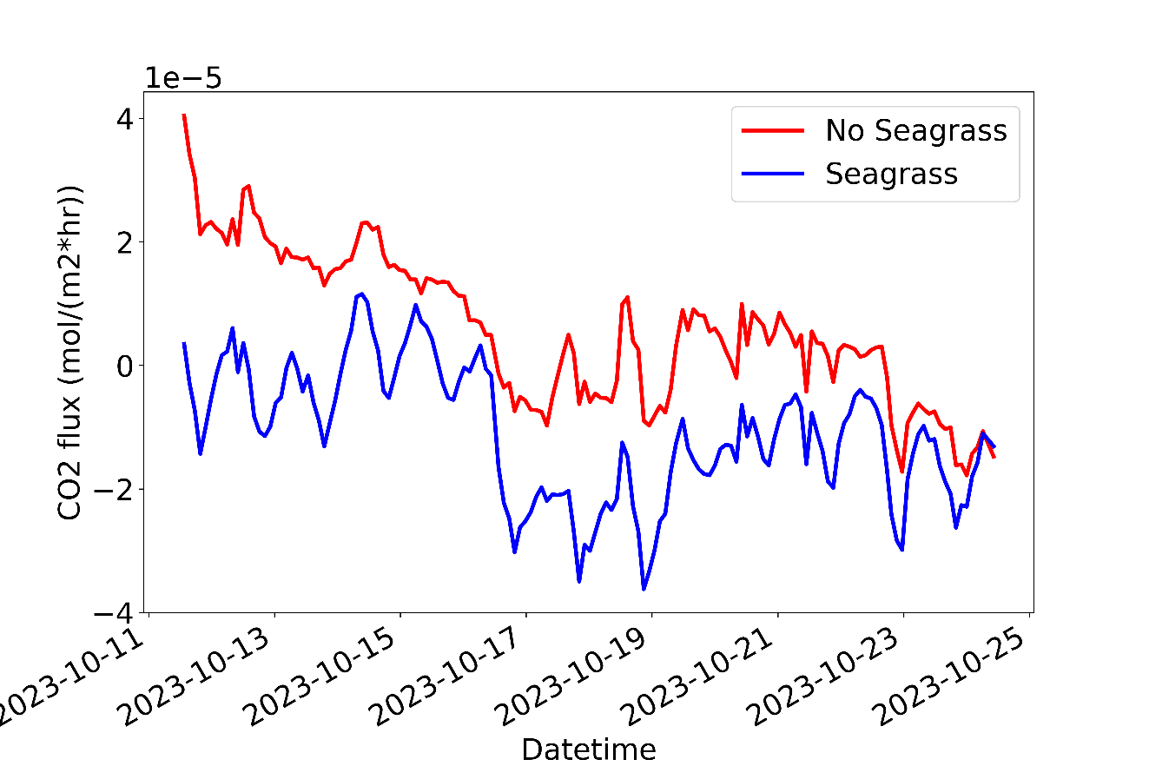

Figure . CO2 fluxes for SEACOW1 and SEACOW4.

# **DISCUSSION**

Sampling pCO2 in marine environments can be logistically difficult and expensive, yet it is one of the most important parameters to monitor as anthropogenic CO2 continues to change the chemistry of the ocean. Not only does monitoring pCO2 give scientists a better understanding of the effects of anthropogenic CO2, but it allows scientists to study many different aspects of oceanography such as the movement of water along the oceanic conveyor belt (Takahashi et al., 2009), the effect pCO2 concentrations have on calcifying organisms (Fujita et al., 2011), or the productivity of a region (Körtzinger et al., 2008). Additionally, there has been an increase in marine carbon dioxide removal (mCDR) groups who are looking for the best ways to monitor the movement of CO2, so they can verify their methods of sequestering CO2 from the atmosphere. Due to labor-intensive and expensive methods of high quality pCO2 sensing, many of these groups and scientists are interested in low-cost pCO2 technologies that can be deployed in larger quantities alongside more expensive, but singular, pCO2 systems. The need for this technology is what inspired the development of the SEACOW.

In addition to developing pCO2 monitoring for artificial carbon dioxide removal, it is similarly important to monitor and protect the habitats that naturally sequester carbon, such as blue carbon habitats. Seagrass meadows are one of these blue carbon habitats, and they may be responsible for 10% of the organic carbon stored by the ocean (Fourqurean et al., 2012; Herr & Landis, 2016). If we develop more ways to monitor the CO2 in seagrass meadows, we can assist in quantifying their importance widely and inexpensively, producing data that can be used to help advocate for their protection. Creating accessible monitoring solutions for seagrass and other blue carbon habitats also largely motivated the development of the SEACOW.

During this project, I led the development of the SEACOW prototype and characterized its accuracy, precision, and deployment parameters after building all the infrastructure to do so and mentoring several undergraduate student researchers. I conducted field deployments to assess its viability as a field instrument and completed a tank experiment for examining the diel pCO2 cycling of seagrass using the SEACOW. One of the main results of this project is the creation of the SEACOW itself, for which I’ve summarized its characterization data below:

Table . Summary of the characterization data for the SEACOW

|  |  |
| --- | --- |
| ***Characterization parameter*** | ***Value*** |
| Accuracy | ± 2% of LI-850’s readings |
| Air side 5τ time | 5.7 minutes |
| Water side 5τ time | ~30 minutes |
| Power draw | 185 mW |
| Drierite budget | 162 grams per 5 days |
| Temperature range | 5-40 ℃ |
| Cost in parts ([bill of materials](https://github.com/COAST-Lab/SEACOW_Public/tree/main/Parts_Needed)) | ~$1400 |
| <https://github.com/COAST-Lab/SEACOW_Public> | |

Although the reported out-of-the-box accuracy for the K30 sensor is ±30 µatm, many studies, including this one, show that K30 accuracy can be greatly improved with additional calibration (Hunt et al., 2017; Wall, 2014; Yasuda et al., 2012). This was evident in the SEACOW’s air side accuracy of ±2% of the LI-850’s readings. Although the same K30 is used for the water side measurements, the water-side accuracy was more difficult to verify, as there was considerable deviation in the pCO2 water samples (Figure 24). If the SEACOW is to be used for field deployments, a minimum timeframe for calibration servicing should be established. However, because the SEACOW measures atmospheric and aquatic pCO2, a ∆pCO2 (pCO2(water) -pCO2(air)) value can be obtained. Therefore, even if the K30 sensor readings start to drift over time, the drift is subtracted out when the difference is taken, allowing the SEACOW to maintain rigor during deployments. This feature, along with the fact that the parts cost ~$1,400, make the SEACOW a valuable contribution to biogeochemical scientific and engineering communities.

As demonstrated in this study, ∆pCO2 values can also be used to calculate CO2 fluxes according to Equations 11 and 12. The commercial equivalent of ∆pCO2/CO2 flux system can cost $32,000 (CO2-Pro, Pro-Oceanus, Canada), so the SEACOW could be an advantageous way to increase spatial resolution of CO2 flux measurements.

The response time for the air side is sufficient for capturing changes in atmospheric CO2 during deployments. However, the water side response time is not as competitive when compared to other pCO2 instruments, such as the SIPCO2 (Hunt et al., 2017) or the CO2-Pro (Pro-Oceanus) which have reported response times of 15 minutes and 12.5 minutes, respectively. The CO2-Pro’s efficient response time could be attributed to its pump that moves water across the equilibration membrane, which also reduces biofouling. The SEACOW’s water side response time could be decreased by adding an external pump or stirring mechanism, which may also assist in biofouling.

The SEACOW’s power draw is relatively low at 185 mW, and a solar panel can be introduced to the system to increase deployment times. Therefore, the power budget is not of concern to future deployments of the SEACOW. However, the drierite budget currently is the largest limiting factor for deployments of the SEACOW. Internal rearranging could be done to increase the amount of drierite that can fit in the SEACOW’s housing, or a different drying mechanism could be introduced.

During the seagrass tank deployments, I demonstrated the capability of the SEACOW to capture diel cycling of pCO2. The relationship between dissolved oxygen (DO) and pCO2 levels in the seagrass tank were as expected (Figure 22), as photosynthesis produced DO during the day and used it for respiration at night. The difference between the DO/pCO2 cycling between the control tank and the seagrass tank was clear, emphasizing the difference was due to the presence of the seagrass. Initially in the experiment (Oct 11-16), the atmospheric pCO2 was cycling inversely of the aquatic pCO2 – rising during the day and falling at night (Figure 22). It is likely that this could have been due to other lab users entering the lab during the day and respiring, which would raise the atmospheric CO2 levels. However, around October 16th, this pattern ceased, as the atmospheric and aquatic pCO2 were rising and falling at the same times of the days. On October 16th, I added a larger quantity of deionized water to the tanks to maintain their salinity, which may have caused the sudden decrease in aquatic pCO2 levels on that day. However, the addition of deionized water should not have affected the atmospheric pCO2 cycling, so it is unknown what caused the change.

While the current SEACOW can go on short field deployments (~5 days), I have several recommendations for its improvement if it is to be used for longer deployments in the future. These are outlined in the Chapter 3 results in detail, but the most pressing improvements for future deployments would be the addition of a solar panel or larger battery pack, adding more drierite to the system/using a different drying mechanism, and decreasing biofouling. These improvements would allow the SEACOW to be deployed alongside more robust systems, like the CO2-Pro (Pro-Oceanus) to increase spatial resolution of sampling.

The increasing popularity of microcontrollers and off-the-shelf parts help improve accessibility of monitoring technologies, which was one of the major goals of this project. Oceanic pCO2 is one of the most important parameters to expand monitoring for, as the ocean absorbs about 25% of the CO2 emitted from human activities every year (Turley et al., 2006). Using low-cost parts, we successfully built a ∆pCO2 monitoring device, characterized its use, and conducted proof-of-concept deployments. While there are more improvements to be made on the SEACOW, its development is an important contribution to the scientific community and those who are interested in the movement of CO2. I hope the SEACOW is used to monitor coastal habitats and similarly important regions in the future, especially as these regions are subject to the anthropogenic climate change.

# **REFERENCES**

Administration, U. S. E. I. (2022). *Annual Electric Generator Report,  Annual Electric Power Industry Report, and  Power Plant Operations Report.*.

Azevedo, G. B. H. (2020). *Spatially-Temporally Resolved Sampling System for Carbon Dioxide Concentration in The Atmospheric Boundary Layer: A Low-Cost UAS Approach* *The University of Oklahoma*]. <https://shareok.org/handle/11244/324315>

Bartenfelder, A., Kenworthy, W. J., Puckett, B., Deaton, C., & Jarvis, J. C. (2022). The Abundance and Persistence of Temperate and Tropical Seagrasses at their Edge-of-range in the western Atlantic Ocean. *Frontiers in Marine Science*, 865.

Bauer, J. E., Cai, W.-J., Raymond, P. A., Bianchi, T. S., Hopkinson, C. S., & Regnier, P. A. G. (2013). The changing carbon cycle of the coastal ocean. *Nature*, *504*(7478), 61-70. <https://doi.org/10.1038/nature12857>

Bresnahan Jr, P. J., Martz, T. R., Takeshita, Y., Johnson, K. S., & LaShomb, M. (2014). Best practices for autonomous measurement of seawater pH with the Honeywell Durafet. *Methods in Oceanography*, *9*, 44-60.

Brändle, J., Conservation Ecology Center, S. C. B. I., ForestGEO, 1500 Remount RD, Front Royal, 22630, VA, USA, Center for Tropical Forest Science-Forest Global Earth Observatory, S. T. R. I., Apartado 0843-03092, Panamá, Republic of Panamá, Kunert, N., Conservation Ecology Center, S. C. B. I., ForestGEO, 1500 Remount RD, Front Royal, 22630, VA, USA, & Center for Tropical Forest Science-Forest Global Earth Observatory, S. T. R. I., Apartado 0843-03092, Panamá, Republic of Panamá. (2022). A new automated stem CO2 efflux chamber based on industrial ultra-low-cost sensors. *Tree Physiology*, *39*(12), 1975-1983. <https://doi.org/10.1093/treephys/tpz104>

Curcoll, R., Morguí, J.-A., Kamnang, A., Cañas, L., Vargas, A., & Grossi, C. (2022). Metrology for low-cost CO<sub>2</sub> sensors applications: the case of a steady-state through-flow (SS-TF) chamber for CO<sub>2</sub> fluxes observations. *Atmospheric Measurement Techniques*, *15*(9), 2807-2818. <https://doi.org/10.5194/amt-15-2807-2022>

Dai, M., Su, J., Zhao, Y., Hofmann, E. E., Cao, Z., Cai, W.-J., . . . Wang, Z. (2022). Carbon Fluxes in the Coastal Ocean: Synthesis, Boundary Processes, and Future Trends. *Annual Review of Earth and Planetary Sciences*, *50*(1), 593-626. <https://doi.org/10.1146/annurev-earth-032320-090746>

Dickson, A. G., Sabine, C. L., & Christian, J. R. (2007). *Guide to best practices for ocean CO2 measurements*. North Pacific Marine Science Organization.

Doney, S. C., Fabry, V. J., Feely, R. A., & Kleypas, J. A. (2009). Ocean acidification: the other CO2 problem. *Annual review of marine science*, *1*, 169-192.

Emanuel, K. A. (1987). The dependence of hurricane intensity on climate. *Nature*, *326*(6112), 483-485. <https://doi.org/10.1038/326483a0>

Fakhraee, M., Planavsky, N., & Reinhard, C. (2022). Ocean Alkalinity Enhancement Through Blue Carbon Ecosystem Restoration.

Farquhar, S., Nirindrainy, A. F., Heck, N., Saldarriaga, M. G., & Xu, Y. (2022). The impacts of long-term changes in weather on small-scale fishers’ available fishing hours in Nosy Barren, Madagascar. *Frontiers in Marine Science*, *9*, 841048.

Field, D., Kenworthy, J., & Carpenter, D. (2021). Why Is the Extent of Submerged Aquatic Vegetation Important Within the Albemarle-Pamlico Estuarine System?

Fine, G. F., Cavanagh, L. M., Afonja, A., & Binions, R. (2010). Metal Oxide Semi-Conductor Gas Sensors in Environmental Monitoring. *Sensors*, *10*(6), 5469-5502. <https://doi.org/10.3390/s100605469>

Fourqurean, J. W., Duarte, C. M., Kennedy, H., Marbà, N., Holmer, M., Mateo, M. A., . . . Serrano, O. (2012). Seagrass ecosystems as a globally significant carbon stock. *Nature Geoscience*, *5*(7), 505-509. <https://doi.org/10.1038/ngeo1477>

Frankignoulle, M. (1988). Field measurements of air-sea CO2 exchange. *Limnology and Oceanography*, *33*(3), 313-322. <https://doi.org/10.4319/lo.1988.33.3.0313>

Fujita, K., Hikami, M., Suzuki, A., Kuroyanagi, A., Sakai, K., Kawahata, H., & Nojiri, Y. (2011). Effects of ocean acidification on calcification of symbiont-bearing reef foraminifers. *Biogeosciences*, *8*(8), 2089-2098.

Gattuso, J.-P., Epitalon, J.-M., Lavigne, H., & Orr, J. (2021). *seacarb: seawater carbonate chemistry*.In <http://CRAN.R-project.org/package=seacarb>

Hales, B., Chipman, D., & Takahashi, T. (2004). High-frequency measurement of partial pressure and total concentration of carbon dioxide in seawater using microporous hydrophobic membrane contactors. *Limnology and Oceanography: Methods*, *2*(11), 356-364. <https://doi.org/10.4319/lom.2004.2.356>

Helm, J., Hartmann, H., Göbel, M., Hilman, B., Herrera Ramírez, D., & Muhr, J. (2021). Low-cost chamber design for simultaneous CO2 and O2 flux measurements between tree stems and the atmosphere. *Tree Physiology*, *41*(9), 1767-1780. <https://doi.org/10.1093/treephys/tpab022>

Herr, D., & Landis, E. (2016). Coastal blue carbon ecosystems. Opportunities for Nationally Determined Contributions. Policy Brief. In: Gland, Switzerland: IUCN and Washington.

Ho, D. T., Wanninkhof, R., Schlosser, P., Ullman, D. S., Hebert, D., & Sullivan, K. F. (2011). Toward a universal relationship between wind speed and gas exchange: Gas transfer velocities measured with 3He/SF6 during the Southern Ocean Gas Exchange Experiment. *Journal of Geophysical Research: Oceans*, *116*(C4).

Hunt, C. W., Snyder, L., Salisbury, J. E., Vandemark, D., & Mcdowell, W. H. (2017). SIPCO2: A simple, inexpensive surface water pCO<sub>2</sub>sensor. *Limnology and Oceanography: Methods*, *15*(3), 291-301. <https://doi.org/10.1002/lom3.10157>

IEA. (2023). *CO2 Emissions in 2022 License*. <https://www.iea.org/reports/co2-emissions-in-2022>

Jiang, L.-Q., Cai, W.-J., & Wang, Y. (2008). A comparative study of carbon dioxide degassing in river- and marine-dominated estuaries. *Limnology and Oceanography*, *53*(6), 2603-2615. <https://doi.org/10.4319/lo.2008.53.6.2603>

Johnson, M. S., Billett, M. F., Dinsmore, K. J., Wallin, M., Dyson, K. E., & Jassal, R. S. (2009). Direct and continuous measurement of dissolved carbon dioxide in freshwater aquatic systems-method and applications. *Ecohydrology*, n/a-n/a. <https://doi.org/10.1002/eco.95>

Körtzinger, A., Send, U., Lampitt, R., Hartman, S., Wallace, D. W., Karstensen, J., . . . DeGrandpre, M. (2008). The seasonal pCO2 cycle at 49 N/16.5 W in the northeastern Atlantic Ocean and what it tells us about biological productivity. *Journal of Geophysical Research: Oceans*, *113*(C4).

Larkum, A. W., ORTH, R. J., DUARTE, C. M., Kuo, J., & Hartog, C. d. (2006). Seagrass morphology, anatomy, and ultrastructure. *Seagrasses: biology, ecologyand conservation*, 51-87.

Levitus, S., Antonov, J. I., Boyer, T. P., Baranova, O. K., Garcia, H. E., Locarnini, R. A., . . . Zweng, M. M. (2012). World ocean heat content and thermosteric sea level change (0-2000 m), 1955-2010. *Geophysical Research Letters*, *39*(10), n/a-n/a. <https://doi.org/10.1029/2012gl051106>

Li, X., Weller, D. E., Gallegos, C. L., Jordan, T. E., & Kim, H.-C. (2007). Effects of watershed and estuarine characteristics on the abundance of submerged aquatic vegetation in Chesapeake Bay subestuaries. *Estuaries and Coasts*, *30*(5), 840-854. <https://doi.org/10.1007/bf02841338>

Lovelock, C. E., & Reef, R. (2020). Variable Impacts of Climate Change on Blue Carbon. *One Earth*, *3*(2), 195-211. <https://doi.org/10.1016/j.oneear.2020.07.010>

Mandayo, G. G., Herrán, J., Castro-Hurtado, I., & Castaño, E. (2011). Performance of a CO2 Impedimetric Sensor Prototype for Air Quality Monitoring. *Sensors*, *11*(5), 5047-5057. <https://doi.org/10.3390/s110505047>

Marbà, N., Arias-Ortiz, A., Masqué, P., Kendrick, G. A., Mazarrasa, I., Bastyan, G. R., . . . Duarte, C. M. (2015). Impact of seagrass loss and subsequent revegetation on carbon sequestration and stocks. *Journal of Ecology*, *103*(2), 296-302. <https://doi.org/10.1111/1365-2745.12370>

Mazzotti, F. J., Pearlstine, L. G., Chamberlain, R., Barnes, T., Chartier, K., & DeAngelis, D. (2007). *Stressor response models for Seagrasses, Halodule wrightii and Thalassia testudnium.* (Final report to the South Florida Water Management District and the U.S..Geological Survey, Issue.

Meyer, J., & Riebesell, U. (2015). Reviews and Syntheses: Responses of coccolithophores to ocean acidification: a meta-analysis. *Biogeosciences*, *12*(6), 1671-1682. <https://doi.org/10.5194/bg-12-1671-2015>

Micheli, F., Bishop, M. J., Peterson, C. H., & Rivera, J. (2008). Alteration of seagrass species composition and function over two decades. *Ecological Monographs*, *78*(2), 225-244.

Miller, S. D., Marandino, C., & Saltzman, E. S. (2010). Ship-based measurement of air-sea CO2 exchange by eddy covariance. *Journal of Geophysical Research*, *115*(D2). <https://doi.org/10.1029/2009jd012193>

Millero, F. J. (2007). The marine inorganic carbon cycle. *Chemical reviews*, *107*(2), 308-341.

Moorman, M. C., Augspurger, T., Stanton, J. D., & Smith, A. (2017). Where's the grass? disappearing submerged aquatic vegetation and declining water quality in lake mattamuskeet. *Journal of Fish and Wildlife Management*, *8*(2), 401-417.

NASA. (2009). *Climate Forcings and Global Warming*. Retrieved November 14 from <https://earthobservatory.nasa.gov/features/EnergyBalance/page7.php>

NASA. (2022). *OCEAN HEAT CONTENT CHANGES SINCE 1955 (NOAA)*. Retrieved November 14 from <https://climate.nasa.gov/vital-signs/ocean-warming/>

Nicholson, D. P., Michel, A. P. M., Wankel, S. D., Manganini, K., Sugrue, R. A., Sandwith, Z. O., & Monk, S. A. (2018). Rapid Mapping of Dissolved Methane and Carbon Dioxide in Coastal Ecosystems Using the ChemYak Autonomous Surface Vehicle. *Environmental Science & Technology*, *52*(22), 13314-13324. <https://doi.org/10.1021/acs.est.8b04190>

Orr, J., Epitalon, J.-M., & Gattuso, J.-P. (2015). Comparison of ten packages that compute ocean carbonate chemistry. *Biogeosciences*, *12*(5), 1483-1510.

Plass, G. N. (1956). The Carbon Dioxide Theory of Climatic Change. *Tellus*, *8*(2), 140-154. <https://doi.org/10.1111/j.2153-3490.1956.tb01206.x>

Potouroglou, M., Bull, J. C., Krauss, K. W., Kennedy, H. A., Fusi, M., Daffonchio, D., . . . Huxham, M. (2017). Measuring the role of seagrasses in regulating sediment surface elevation. *Scientific Reports*, *7*(1). <https://doi.org/10.1038/s41598-017-12354-y>

Prytherch, J., Yelland, M. J., Pascal, R. W., Moat, B. I., Skjelvan, I., & Neill, C. C. (2010). Direct measurements of the CO<sub>2</sub>flux over the ocean: Development of a novel method. *Geophysical Research Letters*, *37*(3), n/a-n/a. <https://doi.org/10.1029/2009gl041482>

Raymond, P. A., Bauer, J. E., & Cole, J. J. (2000). Atmospheric CO2 evasion, dissolved inorganic carbon production, and net heterotrophy in the York River estuary. *Limnology and Oceanography*, *45*(8), 1707-1717. <https://doi.org/10.4319/lo.2000.45.8.1707>

Rosentreter, J. A. (2022). Water-air gas exchange of CO2 and CH4 in coastal wetlands. In *Carbon Mineralization in Coastal Wetlands* (pp. 167-196). Elsevier.

Rosentreter, J. A., Maher, D. T., Ho, D. T., Call, M., Barr, J. G., & Eyre, B. D. (2017). Spatial and temporal variability of CO2 and CH4 gas transfer velocities and quantification of the CH4 microbubble flux in mangrove dominated estuar. *Limnology and Oceanography*, *62*(2), 561-578. <https://doi.org/10.1002/lno.10444>

Sabine, C., Sutton, A., Mccabe, K., Lawrence-Slavas, N., Alin, S., Feely, R., . . . Tilbrook, B. (2020). Evaluation of a New Carbon Dioxide System for Autonomous Surface Vehicles. *Journal of Atmospheric and Oceanic Technology*, *37*(8), 1305-1317. <https://doi.org/10.1175/jtech-d-20-0010.1>

Souter, D., Planes, S., Wicquart, J., Logan, M., Obura, D., & Staub, F. (2020). Status of coral reefs of the world: 2020. *Global Coral Reef Monitoring Network; International Coral Reef Initiative, Australian Institute of Marine Science: Townsville, Australia*.

Sutherland, S., Von Haefen, R., Cao, J., & Eggleston, D. (2021). Economic Valuation of Submerged Aquatic Vegetation in the Albermarle-Pamlico Estuary.

Sutton, A. J., Sabine, C. L., Maenner-Jones, S., Lawrence-Slavas, N., Meinig, C., Feely, R. A., . . . Kozyr, A. (2014). A high-frequency atmospheric and seawater pCO2 data set from 14 open-ocean sites using a moored autonomous system. *Earth System Science Data*, *6*(2), 353-366. <https://doi.org/10.5194/essd-6-353-2014>

Takahashi, T., Feely, R. A., Weiss, R. F., Wanninkhof, R. H., Chipman, D. W., Sutherland, S. C., & Takahashi, T. T. (1997). Global air-sea flux of CO2: An estimate based on measurements of sea–air pCO2 difference. *Proceedings of the National Academy of Sciences*, *94*(16), 8292-8299. <https://doi.org/10.1073/pnas.94.16.8292>

Takahashi, T., Olafsson, J., Goddard, J. G., Chipman, D. W., & Sutherland, S. (1993). Seasonal variation of CO2 and nutrients in the high‐latitude surface oceans: A comparative study. *Global Biogeochemical Cycles*, *7*(4), 843-878.

Takahashi, T., Sutherland, S. C., Wanninkhof, R., Sweeney, C., Feely, R. A., Chipman, D. W., . . . Sabine, C. (2009). Climatological mean and decadal change in surface ocean pCO2, and net sea–air CO2 flux over the global oceans. *Deep Sea Research Part II: Topical Studies in Oceanography*, *56*(8-10), 554-577.

Turley, C., Blackford, J., Widdicombe, S., Lowe, D., Nightingale, P., & Rees, A. (2006). Reviewing the impact of increased atmospheric CO2 on oceanic pH and the marine ecosystem. *Avoiding dangerous climate change*, *8*, 65-70.

Wall, C. M. (2014). Autonomous in situ measurements of estuarine surface PCO₂: instrument development and initial estuarine observations.

Wanninkhof, R. (1992). Relationship between gas exchange and wind speed over the ocean. *J. Geophys. Res.*, *97*, 7373-7381.

Whitmore, K. M., Stewart, N., Encalada, A. C., Suárez, E., & Riveros‐Iregui, D. A. (2021). Spatiotemporal variability of gas transfer velocity in a tropical high‐elevation stream using two independent methods. *Ecosphere*, *12*(7). <https://doi.org/10.1002/ecs2.3647>

Wilson, K. L., & Lotze, H. K. (2019). Climate change projections reveal range shifts of eelgrass Zostera marina in the Northwest Atlantic. *Marine Ecology Progress Series*, *620*, 47-62.

Yang, Q., Dixon, T. H., Myers, P. G., Bonin, J., Chambers, D., Van Den Broeke, M. R., . . . Mortensen, J. (2016). Recent increases in Arctic freshwater flux affects Labrador Sea convection and Atlantic overturning circulation. *Nature Communications*, *7*(1), 10525. <https://doi.org/10.1038/ncomms10525>

Yasuda, T., Yonemura, S., & Tani, A. (2012). Comparison of the Characteristics of Small Commercial NDIR CO2 Sensor Models and Development of a Portable CO2 Measurement Device. *Sensors*, *12*(3), 3641-3655. <https://doi.org/10.3390/s120303641>

Zappa, C. J., Mcgillis, W. R., Raymond, P. A., Edson, J. B., Hintsa, E. J., Zemmelink, H. J., . . . Ho, D. T. (2007). Environmental turbulent mixing controls on air-water gas exchange in marine and aquatic systems. *Geophysical Research Letters*, *34*(10). <https://doi.org/10.1029/2006gl028790>

Zhang, K., Douglas, B. C., & Leatherman, S. P. (2004). Global Warming and Coastal Erosion. *Climatic Change*, *64*(1/2), 41-58. <https://doi.org/10.1023/b:clim.0000024690.32682.48>

# **APPENDIX.**

CO2 MFC calculations:

Assumed constants:

T = Temperature = 23 °C so 296.15 K  
R = 0.0821 (L*atm)/(mol*K)  
P = Room pressure = 1 atm  
C = Desired CO2 concentration in ppm  
MFCN2 = Mass flow controller for N2 is set at 5 Lpm.

Step 1. $M_{N2}= Molar flow rate for N_{2 }\left(\frac{mol}{min}\right)= \frac{P*{MFC}_{N2} }{R*T}$

Step 2. $M_{CO2}= Molar flow rate for {CO}_{2}\left(\frac{mol}{min}\right)= \frac{C*{10}^{-6}*M_{N2}}{1-C*{10}^{-6}}$

Step 3. ${MFC}_{CO2}(Lpm)= \frac{R*T*M_{CO2}}{P}$